About This Toolkit
This Social Media Toolkit makes it easy to share “Leveraging GenAI to Develop Critical Thinking Skills” content across your social media channels. On the following pages, you’ll find ready-to-post images, video, copy, and URL links designed for usage across Facebook, Instagram, LinkedIn, and X. Feel free to edit the post copy to fit your voice and to tag our accounts so we can engage with your posts.

Post 1 - Course Carousel

Post Copy: We’re exposed to more information every day than any generation in history: good, bad, and ugly. This reality makes critical thinking one of the most valuable skills we can develop. Strengthen your ability to make sound decisions with our online course, “Leveraging GenAI to Develop Critical Thinking Skills.”

Explore the course to learn how to enrich your critical thinking.

Optional Hashtags: #GenAI #CriticalThinking #MichiganOnline #LifelongLearning

Page URL: https://myumi.ch/bV8Qr

Primary Image: Secondary Image:
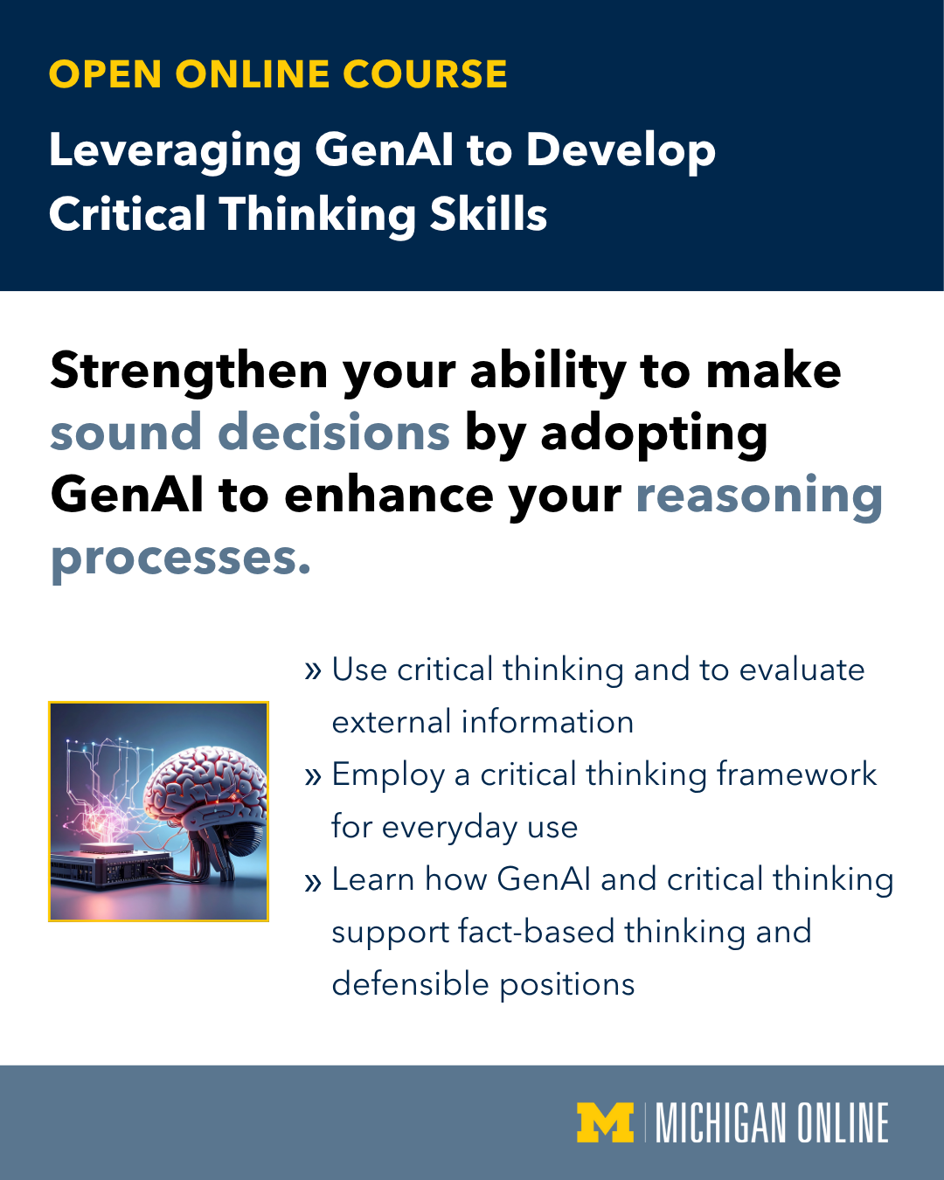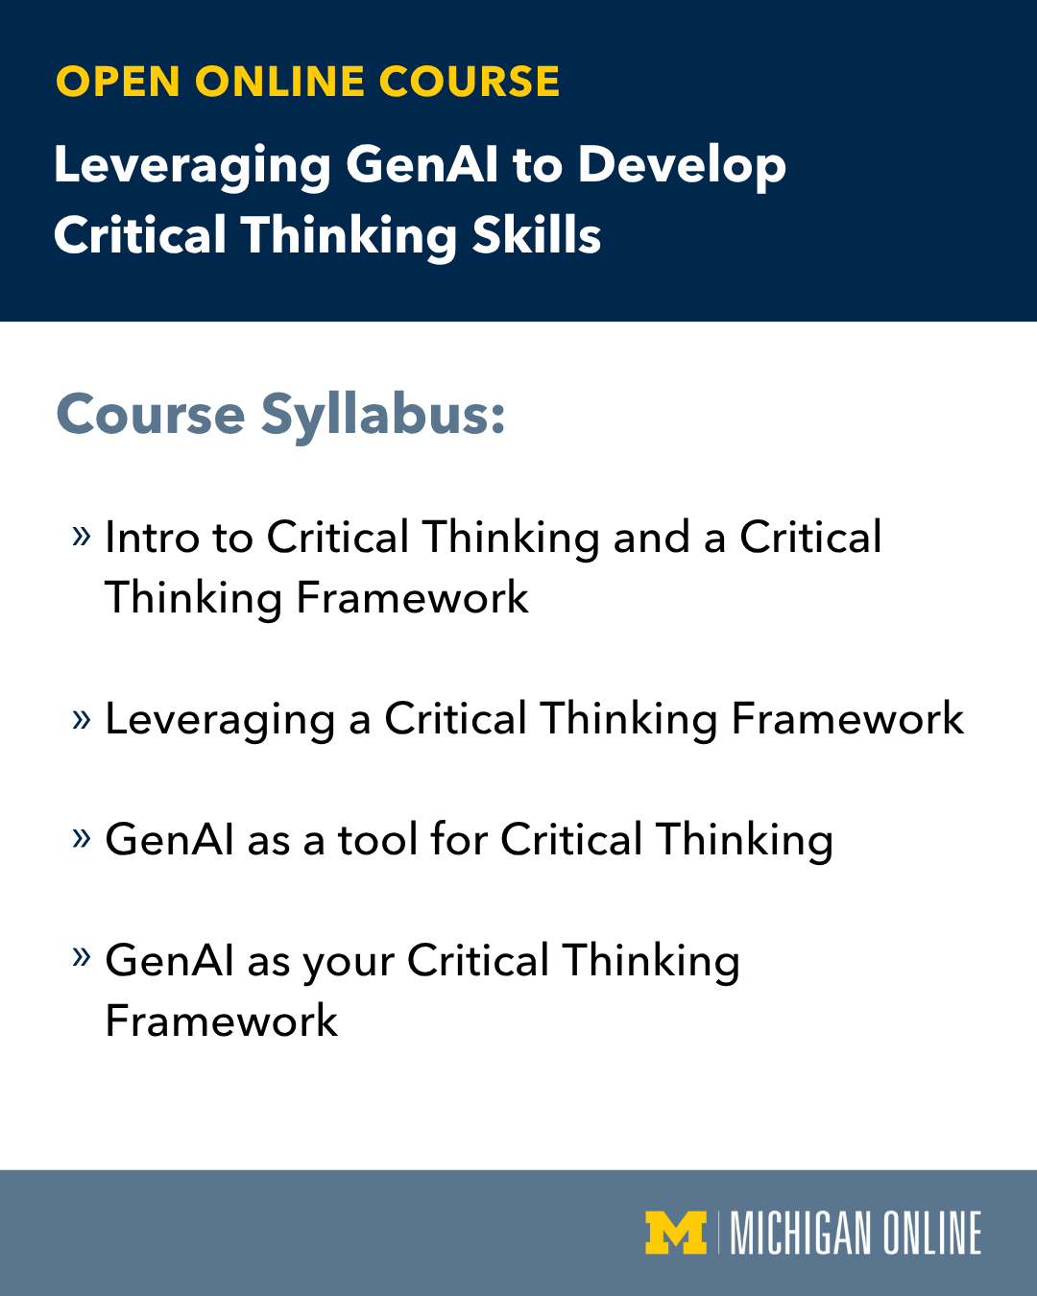

(Click images for downloadable assets)

*See Next page for Alt Text Descriptions

Post 1 Alt Text:

Image 1: Promotional image for a Michigan Online open online course titled 'Leveraging OpenAI to Develop Critical Thinking Skills.' The image features an illustration of a human brain connected to a circuit board, with glowing digital connections and a schematic diagram in the background. Supporting text reads, 'Strengthen your ability to make sound decisions by adopting GenAI to enhance your reasoning processes. Use critical thinking to evaluate external information. Employ a critical thinking framework for everyday use. Learn how GenAI and critical thinking support fact-based thinking and defensible positions.

Image 2: Image displaying a course outline for 'Leveraging GenAI to Develop Critical Thinking Skills' offered by Michigan Online. Text reads, ‘Intro to Critical Thinking and a Critical Thinking Framework. Leveraging a Critical Thinking Framework. GenAI as a tool for Critical Thinking. GenAI as your Critical Thinking Framework.’

Post 2 - Quote Carousel

Post Copy: Many of us have been taught that being “critical” means being unkind. But what if it actually meant being curious?

“Leveraging GenAI to Develop Critical Thinking Skills” is designed by John Thompson from the University of Michigan School of Information to make critical thinking approachable, giving you a clear framework to assess information with clarity and confidence.

Start using AI to build your critical thinking skills today.

Optional Hashtags: #GenAI #CriticalThinking #MichiganOnline #LifelongLearning

Page URL: https://myumi.ch/bV8Qr

Primary Image: Secondary Image:
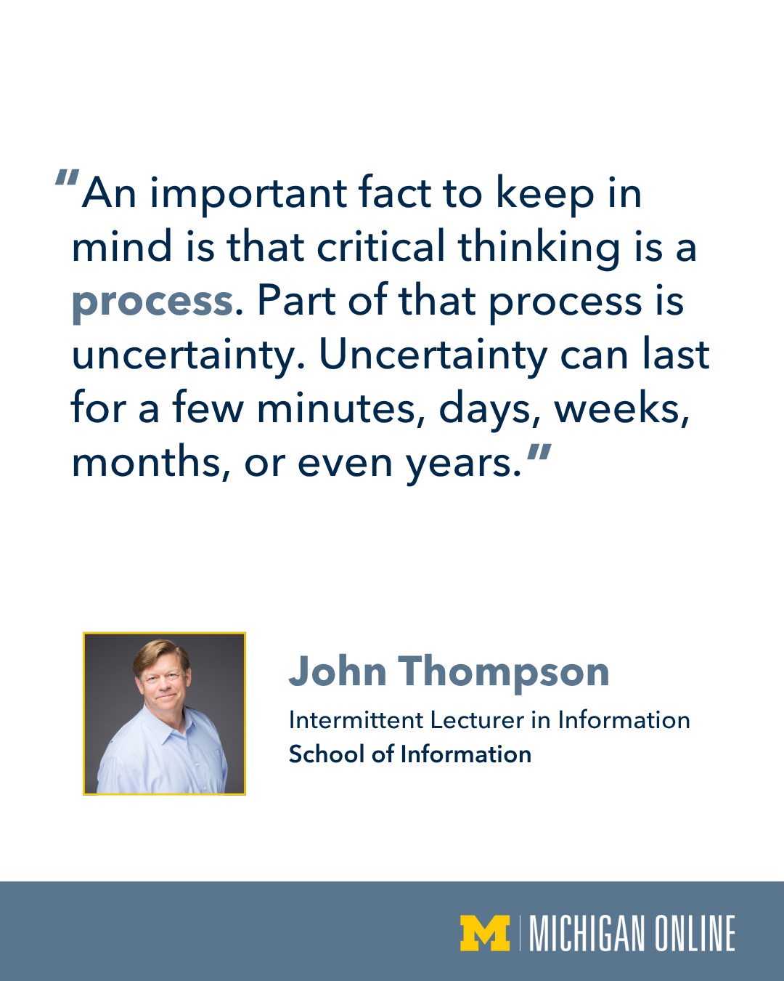

(Click images for downloadable assets)

*See Next page for Alt Text Descriptions

Post 2 Alt Text:

Image 1: Portrait of John Thompson, Intermittent Lecturer in Information from the School of Information. Quote reads, ‘Most people seek certainty and in many cases they will sacrifice accuracy and will not take the time to ensure verification before accepting a piece of information as valid.’

Image 2: Portrait of John Thompson, Intermittent Lecturer in Information from the School of Information. Quote reads, ‘An important fact to keep in mind is that critical thinking is a process. Part of that process is uncertainty. Uncertainty can last for a few minutes, days, weeks, months, or even years.’

Post 3 - Vertical Reel

Post Copy: In an age where we’re surrounded by information, some reliable, some not, critical thinking has become a critical skill.

Let U-M School of Information's John Thompson show you how to review and evaluate information with clarity in “Leveraging GenAI to Develop Critical Thinking Skills.”

Optional Hashtags: #GenAI #CriticalThinking #MichiganOnline #LifelongLearning

Page URL: https://myumi.ch/bV8Qr

Post Video: Optional Post Thumbnail:


(Click images for downloadable assets)

Post 4 - Vertical Reel

Post Copy: Discover how to turn AI into a tool that helps you ask better questions and focus on the skills that matter most to you.

Explore “Leveraging GenAI to Develop Critical Thinking Skills” and learn to evaluate, reason, and make decisions with purpose.

Optional Hashtags: #GenAI #CriticalThinking #MichiganOnline #LifelongLearning

Page URL: https://myumi.ch/bV8Qr

Post Video: Optional Post Thumbnail:


(Click images for downloadable assets)

Post 5 - Vertical Reel

Post Copy: Everyone’s talking about AI, and for good reason.

Through our “Leveraging GenAI to Develop Critical Thinking Skills” course, you’ll learn how to implement a simple framework to boost your confidence, sharpen your thinking, and make better decisions.

Learn how to make AI work for you.

Optional Hashtags: #GenAI #CriticalThinking #MichiganOnline #LifelongLearning

Page URL: https://myumi.ch/bV8Qr

Post Video: Optional Post Thumbnail:


(Click images for downloadable assets)

