About This Toolkit
This Social Media Toolkit makes it easy to share “Sports Betting: Risks and Ripple Effects” content across your channels. On the following pages, you’ll find ready-to-post images, copy, and URL links designed for usage across Facebook, Instagram, LinkedIn, and X. Feel free to edit the post copy to fit your voice across your accounts.

Post 1- Course Graphic Post
Post Copy: Sports betting: Is the gamble worth the risk? ⚽️💸

Many argue that sports betting enhances the enjoyment and suspense of the game for fans, but experts fear the consequences of such a rapid growth in sports betting. From addiction to harassment and game integrity concerns, the unintended ripple effects of this legal and regulated activity are complex and far-reaching.

Our newest Teach-Out™, “Sports Betting: Risks and Ripple Effects,” analyzes the social, legal, and technological forces driving the global surge in sports betting and explores strategies for awareness, empowerment, and harm reduction.

Enroll now:
URL- https://myumi.ch/jJXwz

Primary Image: Secondary Image:
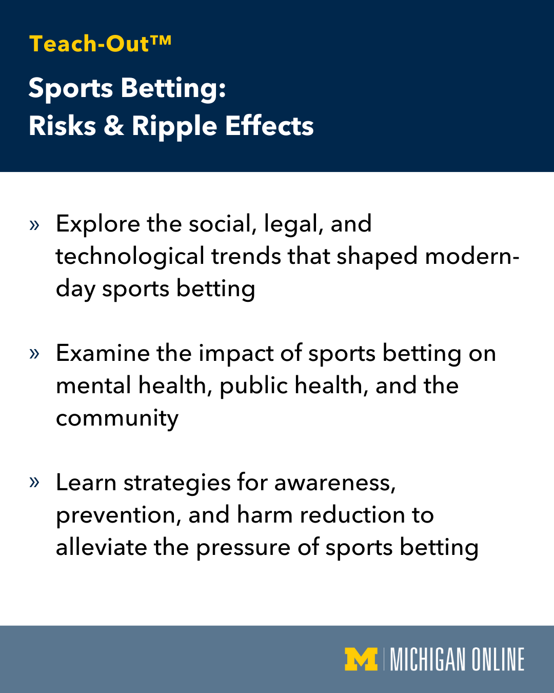
(Click images for downloadable assets)

* See Next Page for Alt Text Descriptions

Post 1 Alt Text:

Image 1: Promotional image for a Michigan Online Teach-Out featuring a close-up of a soccer ball with a background of sports imagery and poker chips, and the text 'Sports Risks & Ripple Effects'. Includes the Michigan Online logo.

Image 2: Promotional image for a Michigan Online "Teach-Out" discussing "Sports betting: Risks & Ripple Effects." Text reads, “Explore the social, legal, and technological trends that shaped modern-day sports betting; examine the impact of sports betting on mental health, public health, and the community; learn strategies for awareness, prevention, and harm reduction to alleviate the pressure of sports betting.”

Post 2 - Quote Carousel

Post Copy: Sport betting has become a massive money maker — but at what cost?

“Sports Betting: Risks & Ripple Effects” provides a broad view of the incentives driving the sports betting industry. In our newest Teach-Out™, we’ll explore the techniques industry leaders use to market to people, examine policies regarding sports betting, and develop strategies to help protect fans and communities.

Learn more:

URL- https://myumi.ch/jJXwz

Carousel Slide 1 Carousel Slide 2

(Click images for downloadable assets)

* See Next Page for Alt Text Descriptions

Post 2 Alt Text:

Image 1: Portrait of Mike Lorenc, clinical assistant sport management professor at the School of Kinesiology, under his quote, “Many of the young adults think of sports betting not as a game of chance or entertainment. They actually believe they can beat the house. So they think of it as a way to make money.” Includes the Michigan Online logo.

Image 2: Portrait of Mike Lorenc, clinical assistant sport management professor at the School of Kinesiology, under his quote, “What I worry about is that rather than growing fans of sports, we might be developing and growing and nurturing gamblers first, sports fans second.” Includes the Michigan Online logo.

Live Event:

Post 3- Single Image Graphic

Post Copy: When the odds favor the house, who pays the price?

Join us for “From Fan Engagement to Gamblification: Ethics and Responsibility in Sports and Esports,” a moderated panel discussion featuring Dr. Lindsey Mortenson and University of Michigan faculty experts as they dive into the ethical tensions and real-world risks of gambling in sports. This live online conversation serves as an extension of our “Sports Betting: Risks & Ripple Effects” Teach-Out™, bridging the gap between emerging research and the lived experience of fans.

Reserve Your Spot:

URL- https://myumi.ch/W632k

Post 3 Image:
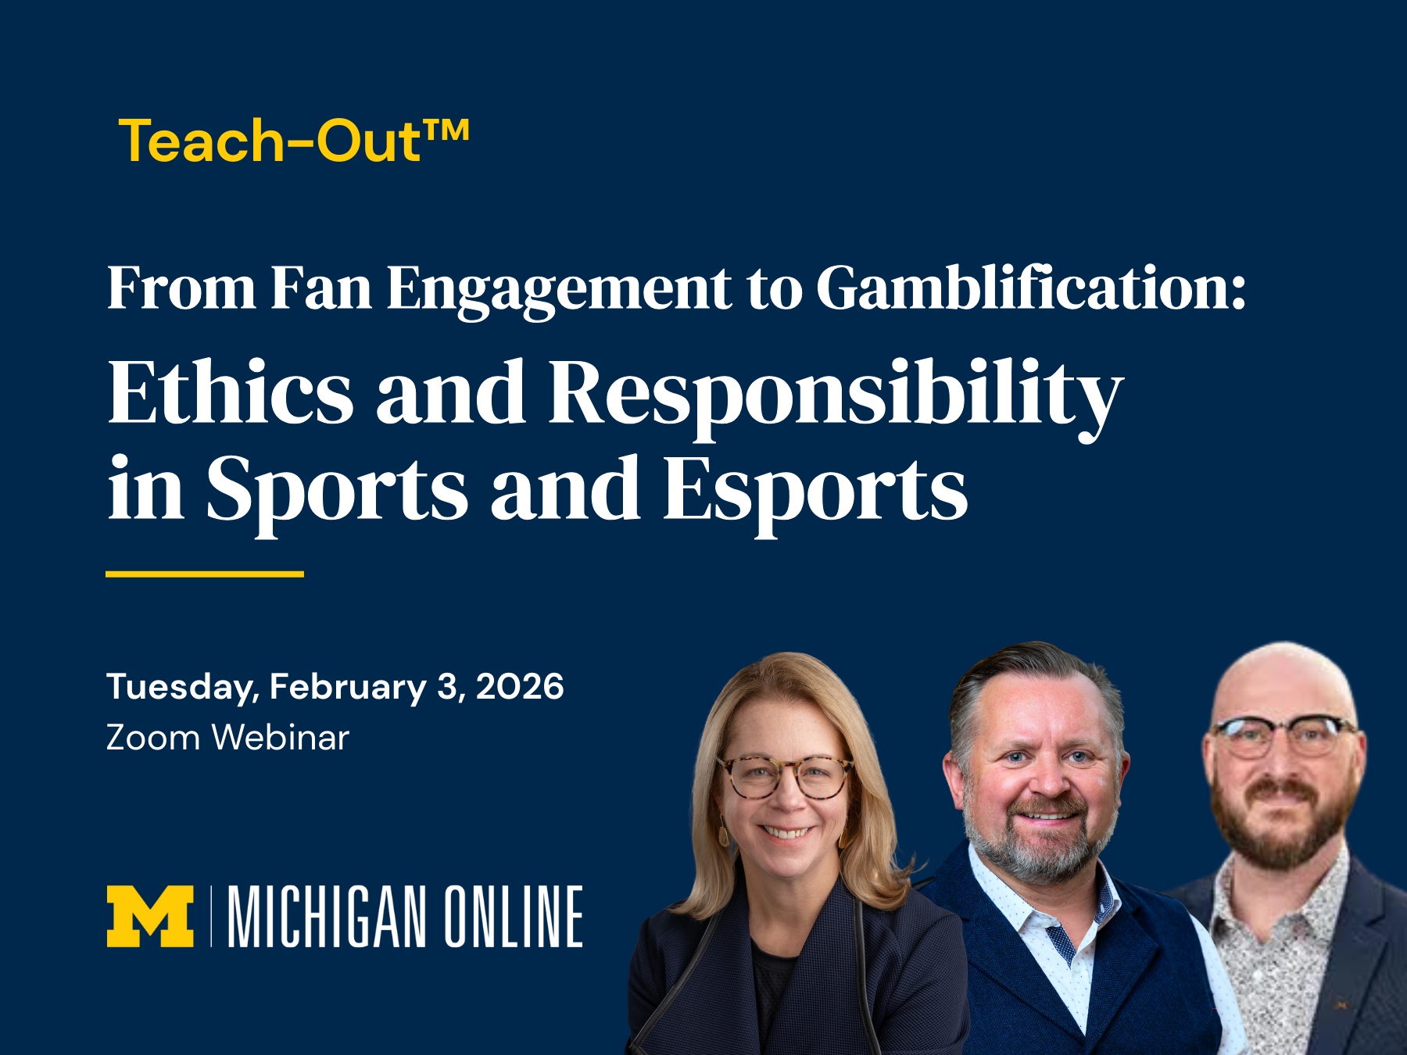
(Click image for downloadable asset)

Alt Text: Promotional graphic for a Michigan Online Teach-Out Zoom event titled "From Fan Engagement to Gamification: Ethics and Responsibility in Sports and Esports," scheduled for Tuesday, February 3, 2026. The image features three speakers against a navy background, with the Michigan Online logo displayed.

Live Event:

Post 4- Single Image Graphic

Post Copy: Sports betting is fundamentally changing how fans around the globe engage with the game.

Join Dr. Lindsey Mortenson and U-M faculty experts for a live online panel event exploring the ethical tensions behind this local and global shift.

February 3, 2026
12 p.m. - 1 p.m.
Zoom Webinar

Designed as a companion to our “Sports Betting: Risks & Ripple Effects” Teach-Out™, this event invites learners to engage in thoughtful dialogue around what this explosive industry shift means for individuals, communities, and the game itself.

Register Now:

URL- https://myumi.ch/W632k

Post 4 Image:

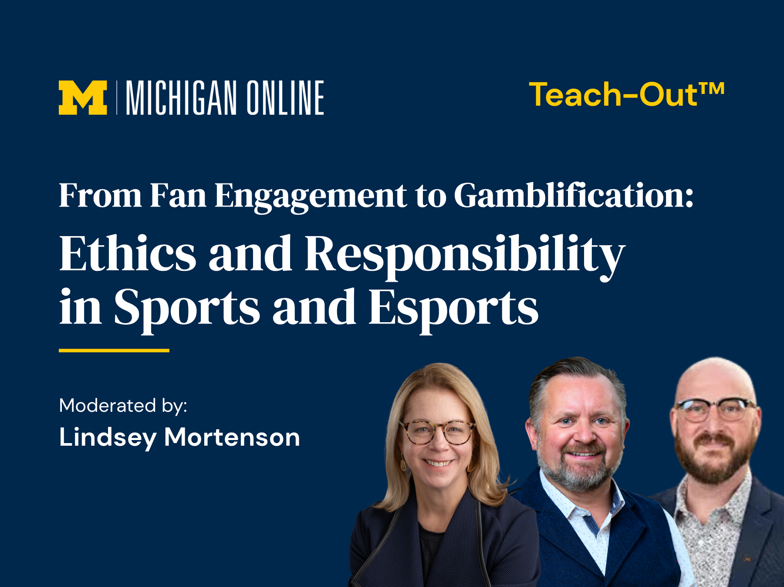

(Click image for downloadable asset)

Alt Text: Promotional graphic for a Michigan Online Teach-Out Webinar event titled "From Fan Engagement to Gamification: Ethics and Responsibility in Sports and Esports," moderated by Lindsey Mortenson. The image features three speakers against a navy background, with the Michigan Online logo displayed.

