About This Toolkit
This Social Media Toolkit makes it easy to share “Applied AI: Data Analysis, Workflows, and Decisions” content across your social channels. On the following pages, you’ll find ready-to-post graphics and/or videos, copy, and URL links designed for usage across Facebook, Instagram, LinkedIn, and X. Feel free to edit the post copy to fit your voice across your accounts.

We’d love it if you tagged us!

Facebook- @MichiganOnline
Instagram- @michigan.online
LinkedIn- @Michigan Online

Course Graphic:

(Click image for downloadable asset)

Alt Text: Three white, futuristic robots with large camera-lens eyes appear against a geometric blue background. Colorful horizontal bands with small technology icons run across the image, while the robot in the foreground holds a translucent rectangular paper.

Individual Course Graphics:

Alt Text Image 1: A friendly white robot with camera-like eyes stands surrounded by colorful charts, graphs, and analytics symbols on a geometric green background.

Alt Text Image 2: A futuristic white robot with large camera-like eyes raises one hand against a gold geometric background, surrounded by icons representing email, cloud services, messaging, documents, websites, and communication tools.

Alt Text Image 3: A white robot with large camera-like eyes stands behind a translucent paper in the center of a blue geometric background. Around the robot are icons representing data analytics and technology, including a server stack, battery, microchip, bar chart, area graph, and circular dashboard graphic

Course 1 Course 2

Course 3


(Click images for downloadable assets)

Post 1- Course Graphic Carousel:

Post Copy: Generative AI is changing how we work with data, and you don’t need a technical background to get started.

In our newest online course series “Applied AI: Data Analysis, Workflows, and Decisions,” you’ll learn how to use AI to explore, organize, and analyze data using a practical, beginner-friendly process.

CTA: Explore the series through Michigan Online.

Hashtags: #GenerativeAI #DataAnalysis #ProfessionalDevelopment

URL: https://myumi.ch/Pb1Aq

Slide 1 Slide 2
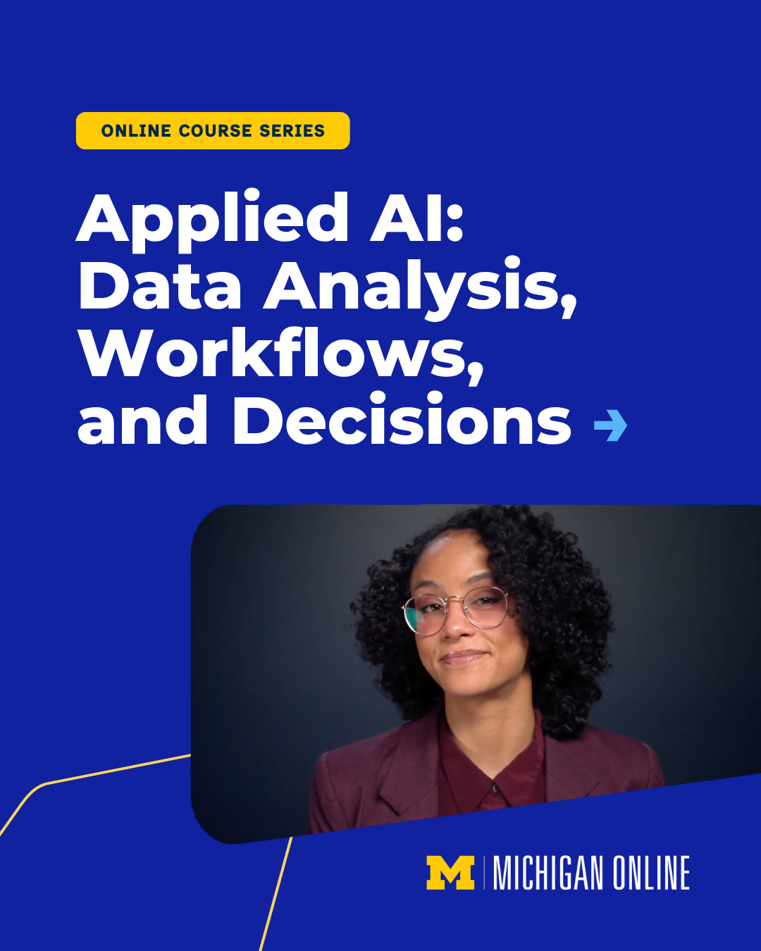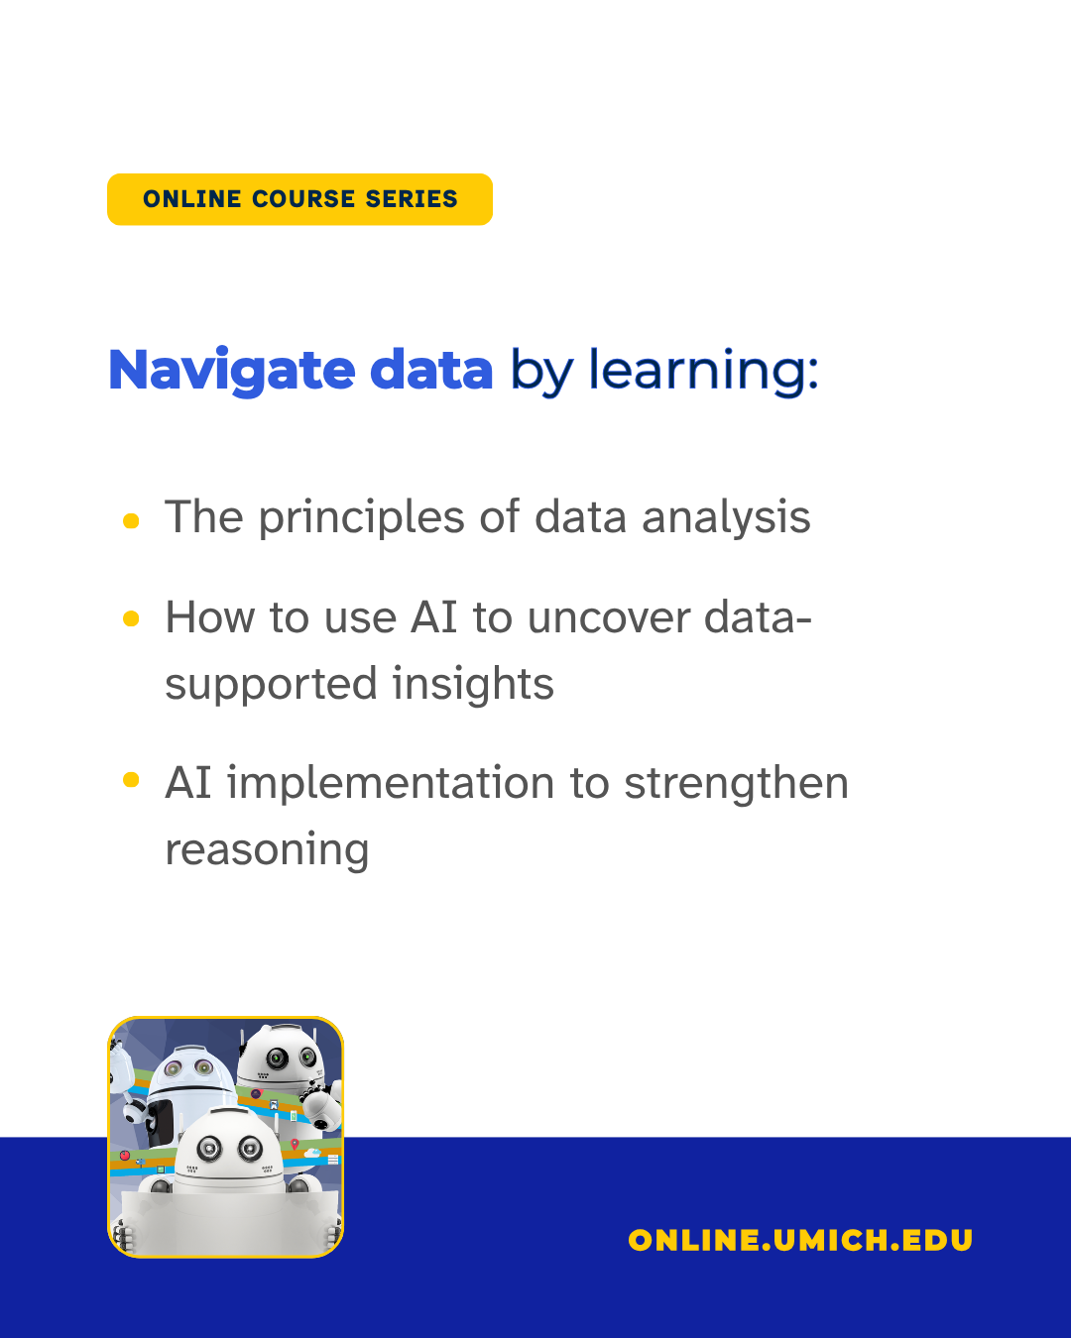

Slide 3 Slide 4
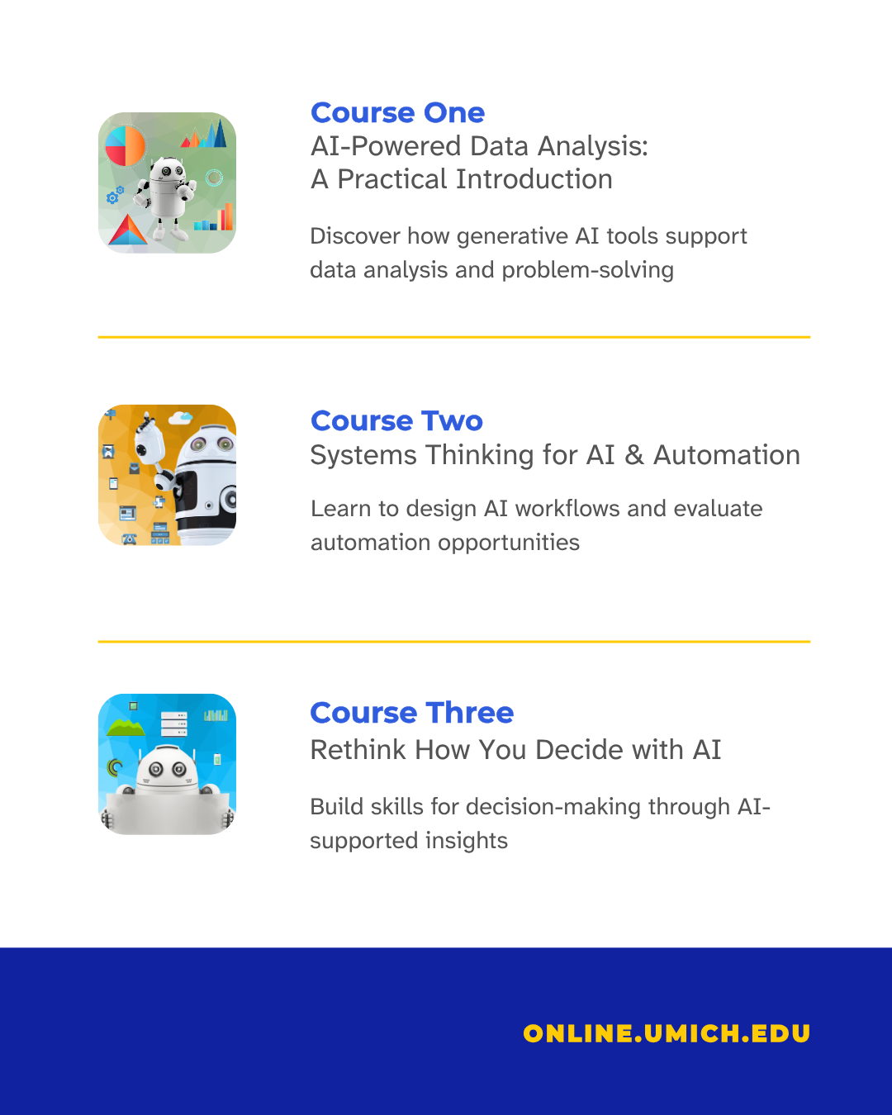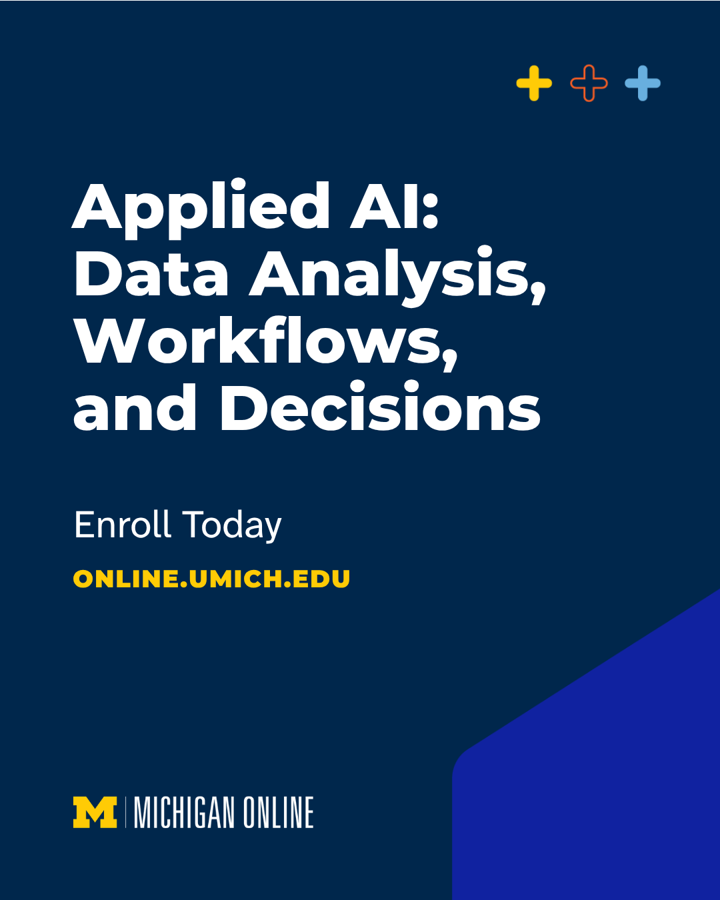

(Click images for downloadable assets)

Course Graphic Carousel Alt Text:

Alt Text Slide 1: Promotional graphic for a University of Michigan Online three-course series titled “Applied AI: Data Analysis, Workflows, and Decisions,” featuring a portrait of a woman wearing glasses against a dark background.

Alt Text Slide 2: University of Michigan Online promotional graphic with a yellow “3-Course Series” label and the headline “Navigate data by learning:”. Three bullet points list learning outcomes: principles of data analysis, using AI to uncover data-supported insights, and implementing AI to strengthen reasoning. A small illustration of three robots appears at the bottom left, and the website online.umich.edu is displayed at the bottom.

Alt Text Slide 3: Graphic listing three courses in an AI-focused program. Course One is “AI-Powered Data Analysis: A Practical Introduction,” covering generative AI tools for data analysis and problem-solving. Course Two is “Systems Thinking for AI & Automation,” focused on designing AI workflows and evaluating automation opportunities. Course Three is “Rethink How You Decide with AI,” focused on decision-making through AI-supported insights. Small robot illustrations accompany each course, and the website online.umich.edu appears at the bottom.

Alt Text Slide 4: Promotional graphic with the headline “Applied AI: Data Analysis, Workflows, and Decisions” in large white text on a dark blue background. The graphic includes the call to action “Enroll Today,” the website online.umich.edu, and Michigan Online branding at the bottom.

Post 2 - Quote Graphic(s):

Post Copy: The ability to ask better questions is a valuable skill in the age of AI.

In the “Applied AI: Data Analysis, Workflows, and Decisions” series, @umichlsa Assistant Professor Tina Lasisi explores how to use AI to analyze information and support decision-making.

CTA: Develop practical AI skills for work and life.

Hashtags: Hashtags: #GenerativeAI #DataAnalysis #ProfessionalDevelopment

URL: https://myumi.ch/Pb1Aq

Primary Image: Secondary Image:

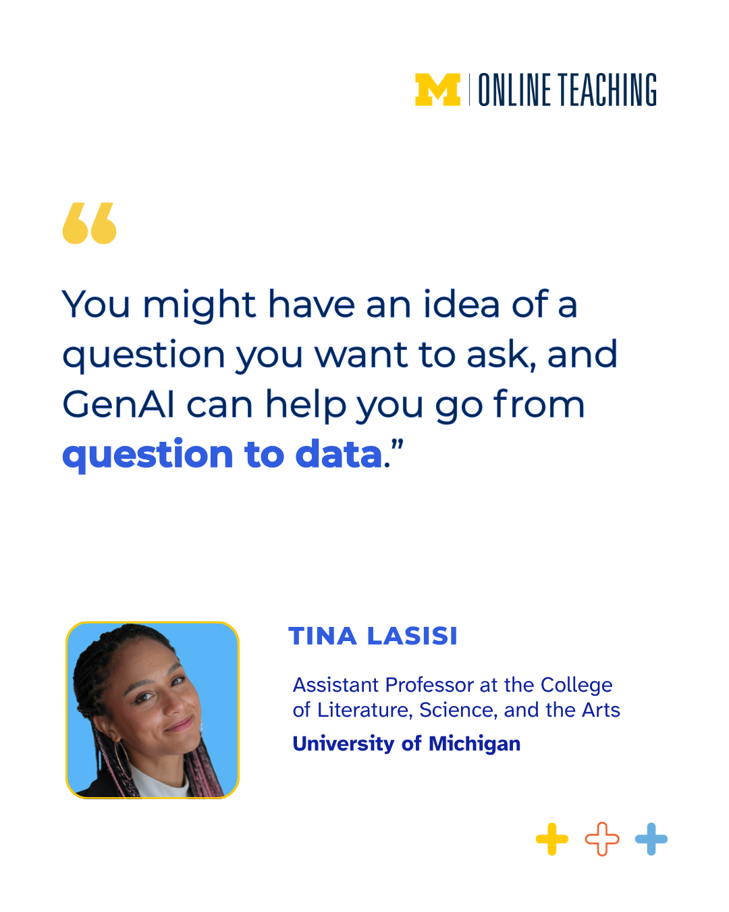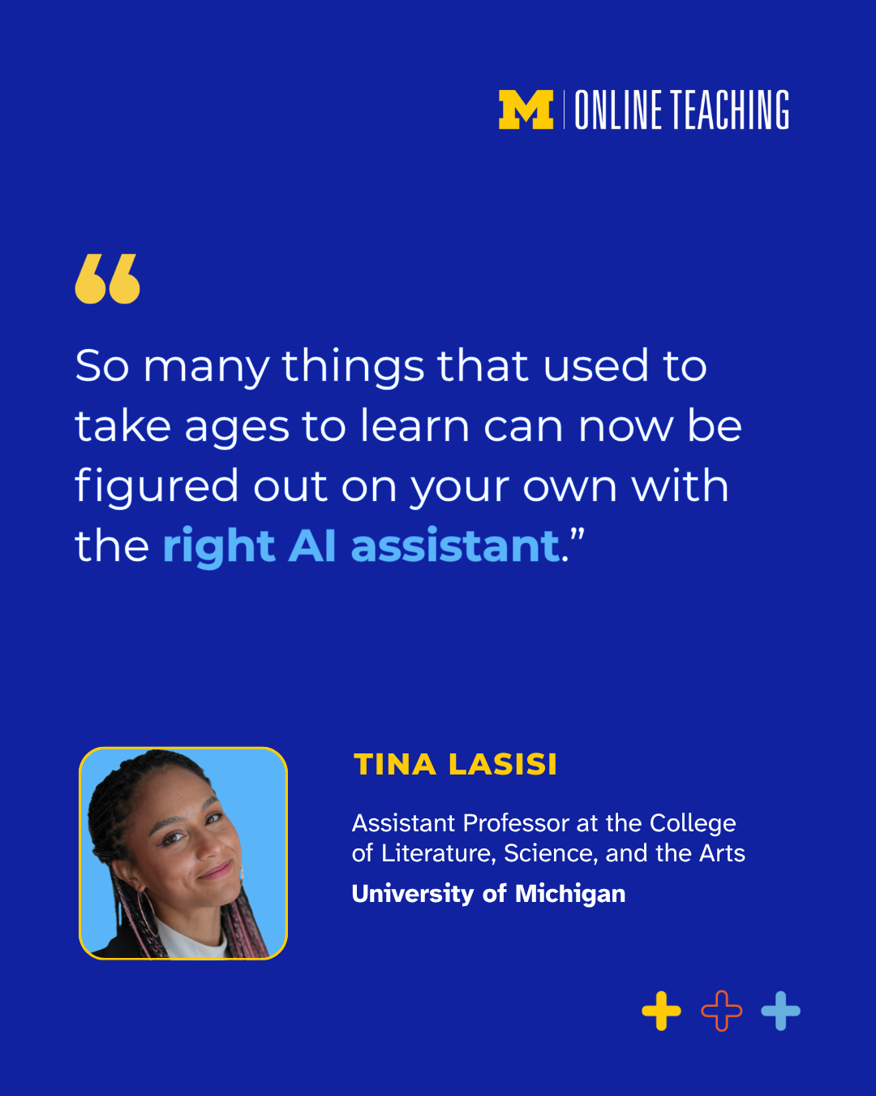

(Click image for downloadable asset)

Alt Text Primary Image: Michigan Online quote graphic with the statement, “You might have an idea of a question you want to ask, and GenAI can help you go from question to data.” Below the quote is a headshot of Tina Lasisi, Assistant Professor in the College of Literature, Science, and the Arts at the University of Michigan.

Alt Text Secondary Image: Michigan Online quote graphic with the statement, “So many things that used to take ages to learn can now be figured out on your own with the right AI assistant.” Below the quote is a headshot of Tina Lasisi, Assistant Professor in the College of Literature, Science, and the Arts at the University of Michigan.

Post 3 - Graphic Image Post:

Post Copy: AI has become part of how we learn, work, and solve problems. But do you use it well?

Explore strategic ways to work with AI, from analyzing data and designing workflows to making thoughtful, informed decisions.

In the three-course “Applied AI: Data Analysis, Workflows, and Decisions” series, you’ll learn how to:
- Use AI tools to support data analysis
- Design workflows that combine AI and human judgment
- Develop decision-making strategies informed by AI insights

Build a foundation for working with AI that goes beyond prompting.

CTA: Develop practical AI skills with Michigan Online.

Hashtags: #GenerativeAI #DataAnalysis #ProfessionalDevelopment

URL: https://myumi.ch/Pb1Aq

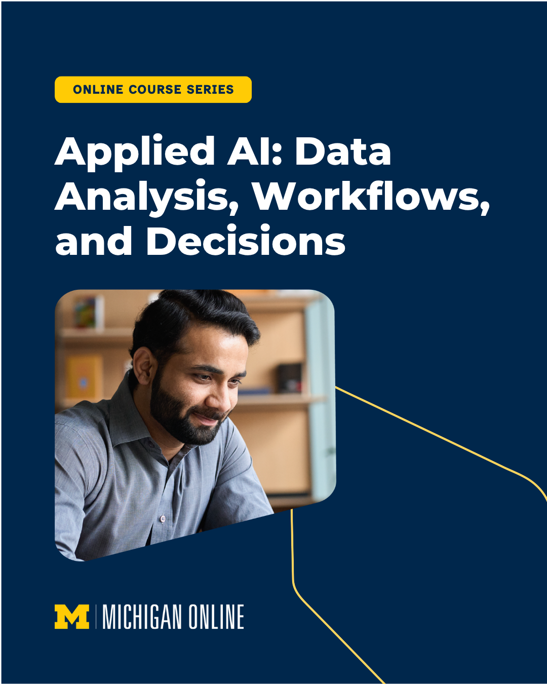

(Click image for downloadable asset)

Alt Text: Promotional graphic with a yellow “3-Course Series” label and the title “Applied AI: Data Analysis, Workflows, and Decisions” in large white text on a dark blue background. Below the title is a photo of a bearded man in a gray shirt smiling while looking down at a computer screen. Michigan Online branding appears at the bottom.

Post 4 - Vertical Reel 1

Post Copy: Speak like yourself. AI will keep up.

In the “Applied AI: Data Analysis, Workflows, and Decisions” series, you’ll use AI to examine information, build strategies, and support decision-making. No tech-speak required.

CTA: Explore the series.

Hashtags: #GenerativeAI #DataAnalysis #ProfessionalDevelopment

URL: https://myumi.ch/Pb1Aq

Vertical Reel 1: Optional Post Thumbnail:


(Click images for downloadable assets)

Post 5 - Vertical Reel 2

Post Copy: Imagine having your own assistant ready to help you brainstorm ideas, organize information, and walk through complex problems. Sounds pretty great, right?

“Applied AI: Data Analysis, Workflows, and Decisions,” taught by @umichlsa assistant professor Tina Lasisi, explores how to onboard AI as a valuable partner in work and life.

CTA: Learn how to make AI work for you.

Hashtags: #GenerativeAI #DataAnalysis #ProfessionalDevelopment

URL: https://myumi.ch/Pb1Aq

Vertical Reel 2 Optional Post Thumbnail:


(Click images for downloadable assets)

Post 6 - Vertical Reel 3

Post Copy: The best use of AI depends on what matters to YOU.

In the “Applied AI: Data Analysis, Workflows, and Decisions” series, @University of Michigan Assistant Professor Tina Lasisi takes a tailored approach. Instead of focusing on productivity for productivity’s sake, she explores how AI can help you strengthen the work that’s meaningful to you.

CTA: Develop practical ways to make AI work for you:

Hashtags: #GenerativeAI #DataAnalysis #ProfessionalDevelopment

URL: https://myumi.ch/Pb1Aq

Vertical Reel 2 Optional Post Thumbnail:


(Click images for downloadable assets)

