About This Toolkit
This Social Media Toolkit makes it easy to share “Realizing AI for Social Impact” content across your social channels. On the following pages, you’ll find ready-to-post graphics and/or videos, copy, and URL links designed for usage across Facebook, Instagram, LinkedIn, and X. Feel free to edit the post copy to fit your voice across your accounts.

We’d love it if you tagged us!

Facebook- @MichiganOnline
Instagram- @michigan.online
LinkedIn- @Michigan Online

Series Course Graphic:


(Click image for downloadable asset)

Alt Text: Futuristic human-like head made of greenery and glowing circuits overlooks a modern city nestled in a lush valley under a star-filled sky.

Individual Course Graphics:

Alt Text Image 1: A clouded leopard stands in a forest scene, highlighted by a bright green detection box against a digital, data-themed background.

Alt Text Image 2: A six-wheeled robotic rover with a raised camera arm and sensors is shown on a dark surface, resembling a planetary explorer. The background features a blue digital overlay with glowing data points, charts, and network lines.

Alt Text Image 3: A person in a checkered shirt holds and interacts with a tablet above a bed of green plants. A blue digital overlay with a rising line chart and network connections suggests data analysis in agriculture.

Course 1 Course 2
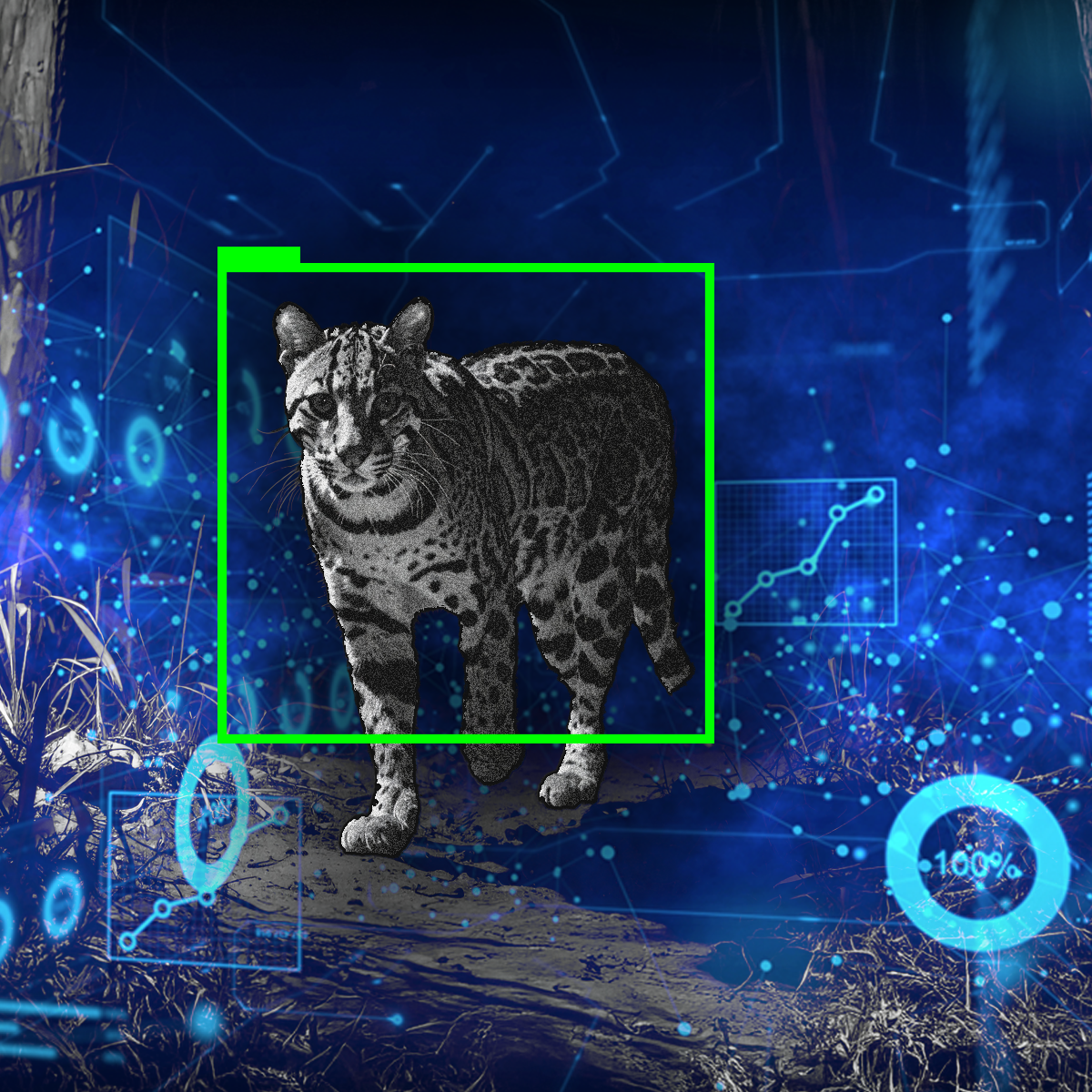
Course 3


(Click images for downloadable assets)

Post 1- Course Graphic Carousel:

Post Copy:
Community first. AI second.

AI is being integrated in diverse fields, including public health, education, and conservation. But without the right approach, it can miss the people it’s meant to serve. Our new course series, “Realizing AI for Social Impact,” explores how to build AI systems that are technically sound and socially responsible.

CTA: Explore this series now.

Hashtags: #AIForGood #SocialImpact #EthicalAI

URL: https://myumi.ch/RQ1w9

Slide 1 Slide 2
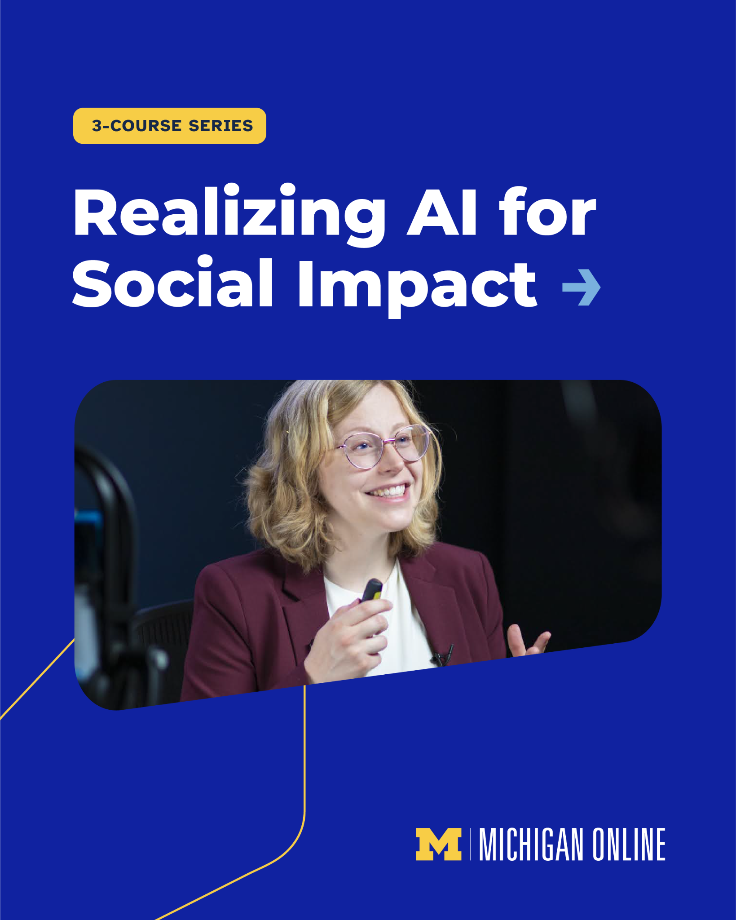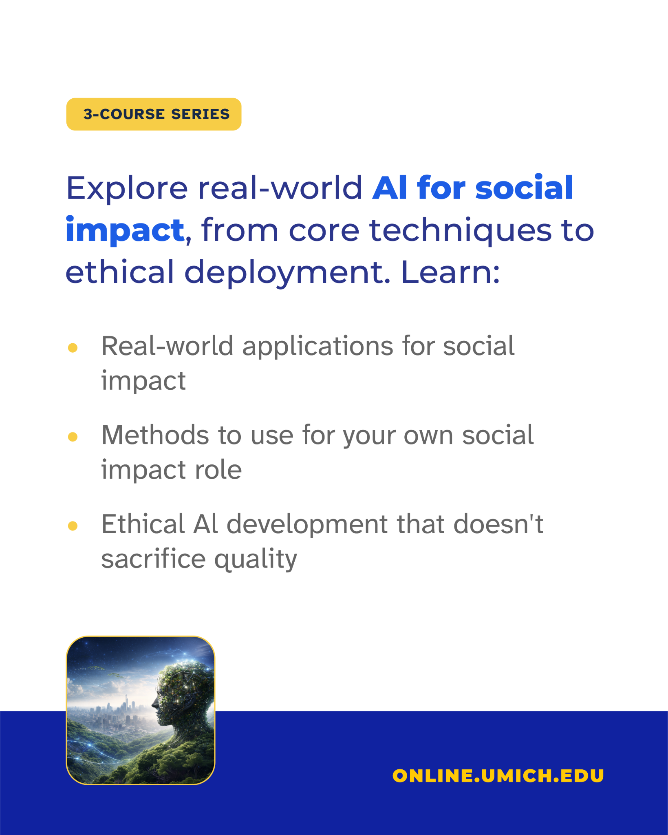

Slide 3 Slide 4
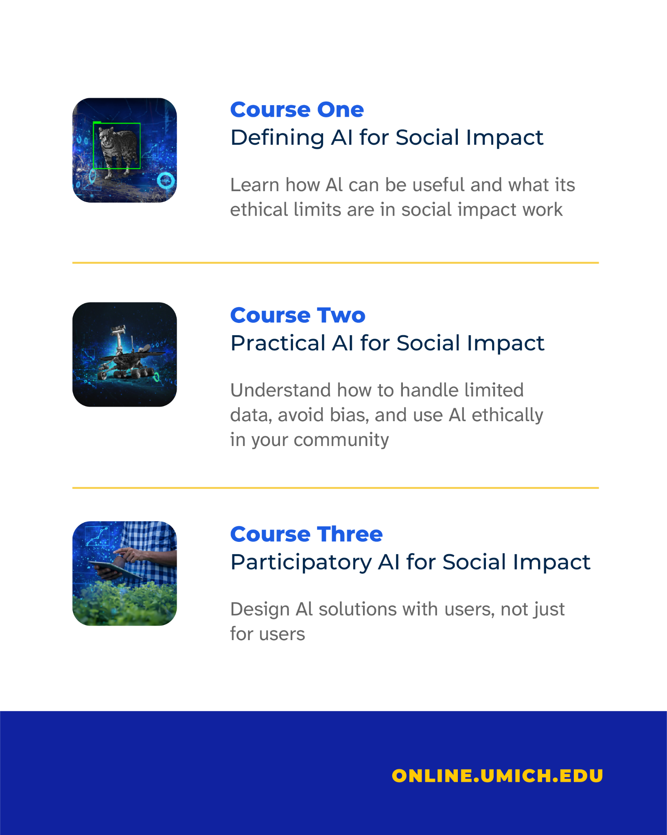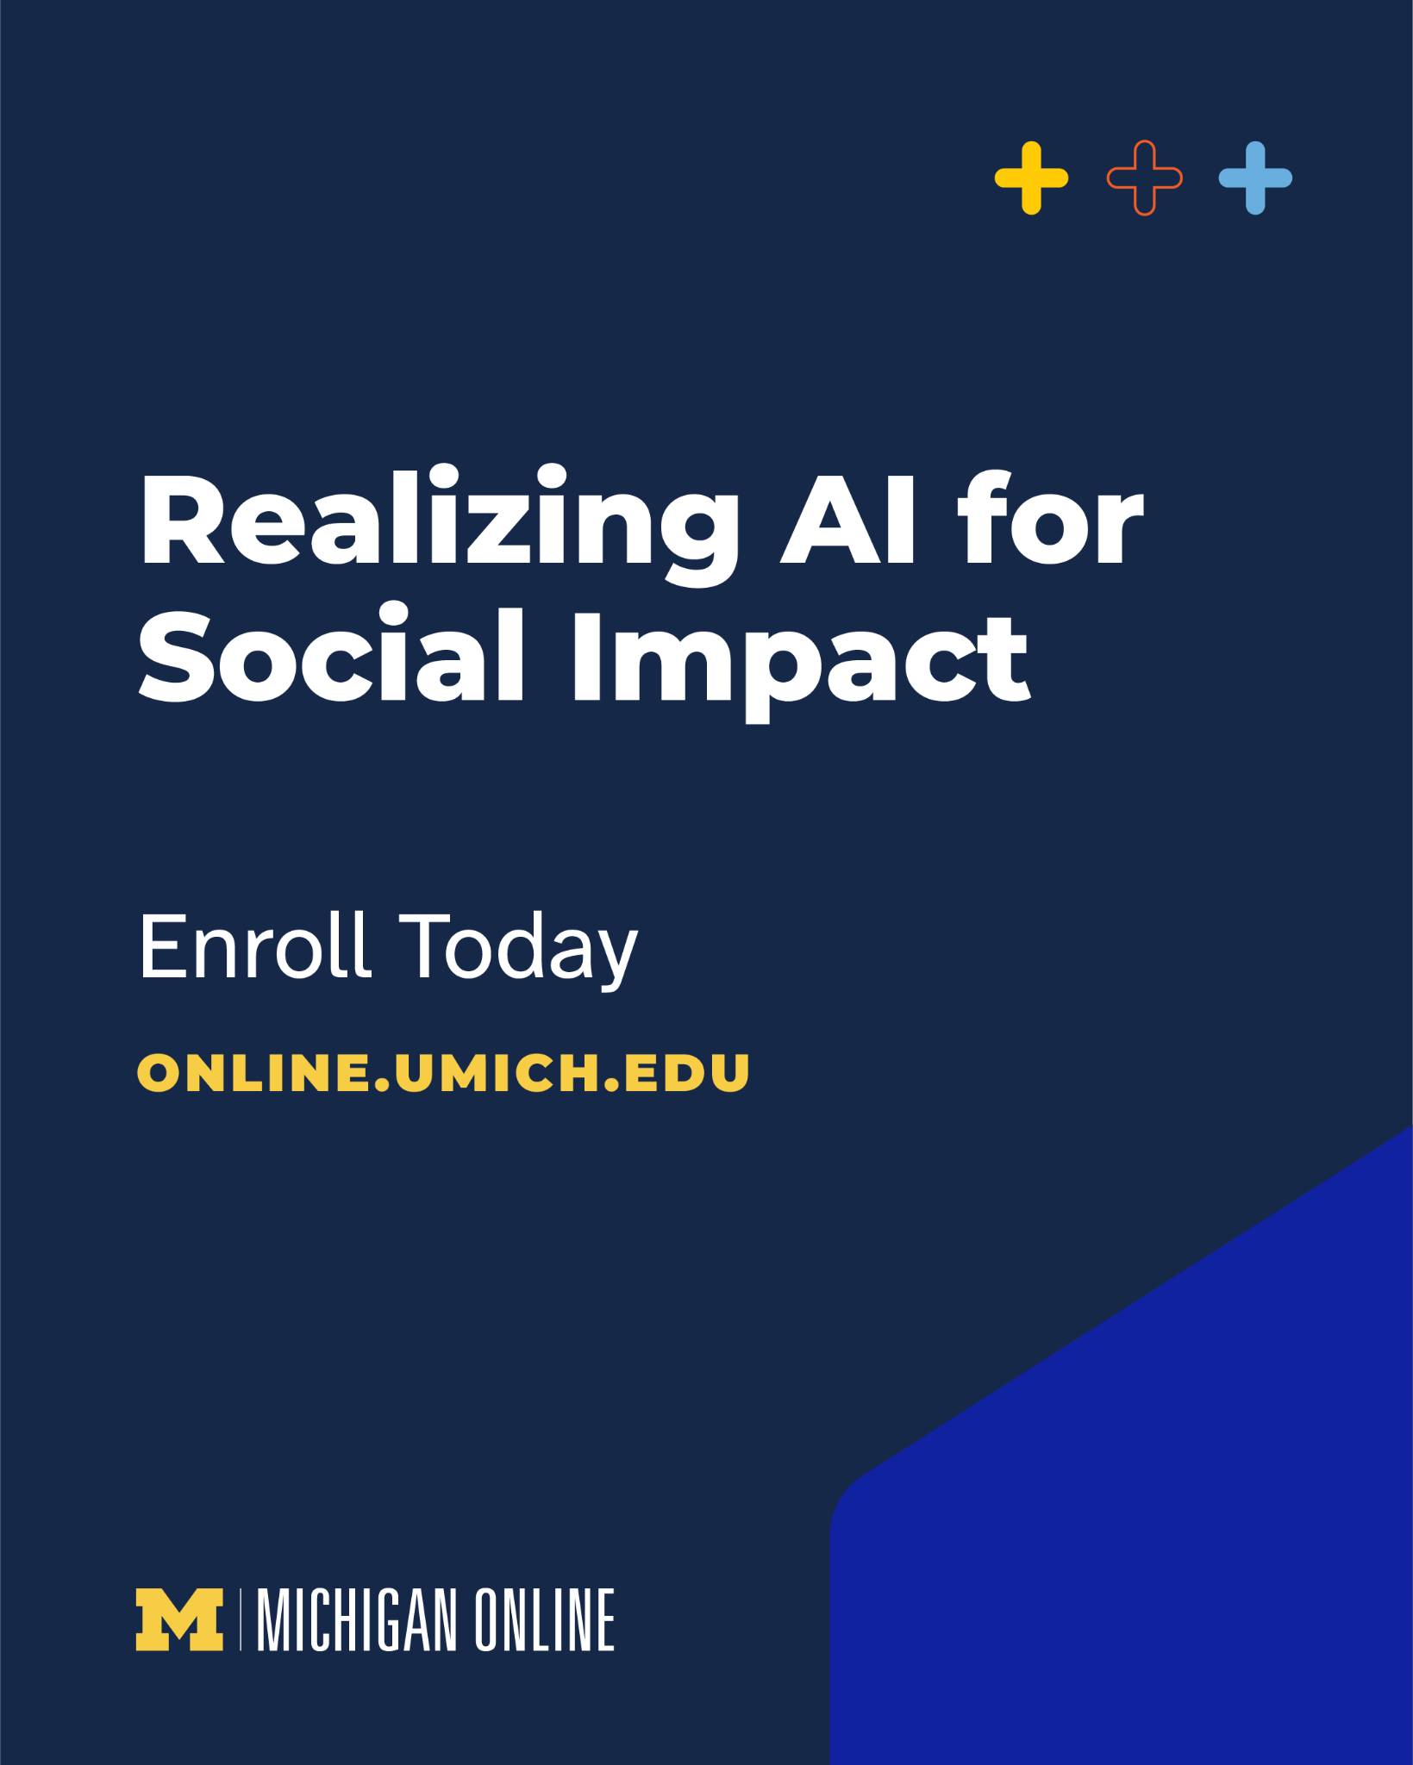

(Click images for downloadable assets)

Course Graphic Carousel Alt Text:

Alt Text Slide 1: Alt Text: Promotional graphic for a “3-Course Series” titled “Realizing AI for Social Impact” on a bright blue background, featuring a smiling woman speaking and holding a presentation remote. The Michigan Online logo appears at the bottom.

Alt Text Slide 2: Light gray promotional graphic advertising a “3-Course Series” focused on “AI for social impact.” The text highlights learning outcomes, including real-world applications, methods for social impact roles, and ethical AI development. A small illustration at the bottom shows a human profile made of greenery and technology overlooking a futuristic cityscape, with “ONLINE.UMICH.EDU” displayed on a blue footer.

Alt Text Slide 3: Light gray course overview graphic listing three courses in an AI for social impact series. “Course One” focuses on defining AI for social impact, “Course Two” covers practical AI for social impact, and “Course Three” explores participatory AI for social impact. Each course section includes a small blue-toned image related to technology, robotics, or digital tools, with “ONLINE.UMICH.EDU” displayed in a blue footer.

Alt Text Slide 4: Dark blue promotional graphic reading “Realizing AI for Social Impact” with a call to action to enroll at ONLINE.UMICH.EDU and Michigan Online branding at the bottom.

Post 2 - Quote Graphic(s):

Post Copy:
We’re seeing the limitations of AI: missing data, biased outcomes, and communities left out of the process. It’s clear that working with AI has real and human consequences.

Our three-course series, “Realizing AI for Social Impact,” created by Elizabeth Bondi-Kelly, assistant professor of electrical engineering and computer science at the University of Michigan, explores the practical and ethical considerations of employing AI and how to use AI for good.

CTA: Explore the series now.

Hashtags: #AIForGood #SocialImpact #EthicalAI

URL: https://myumi.ch/RQ1w9

Primary Image: Secondary Image:
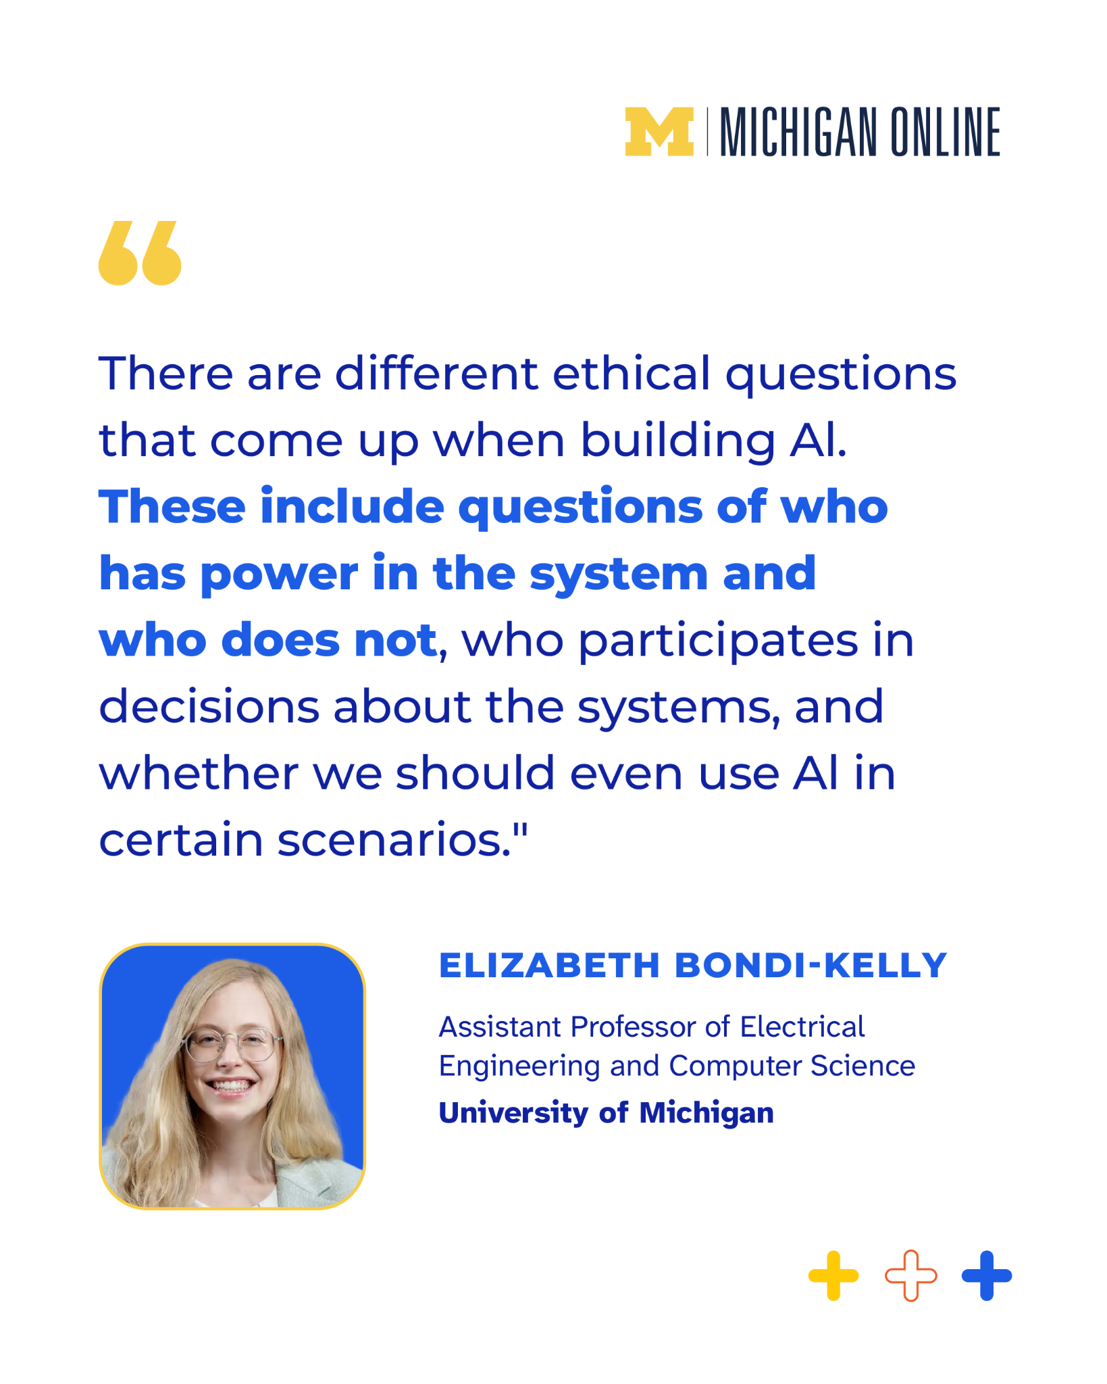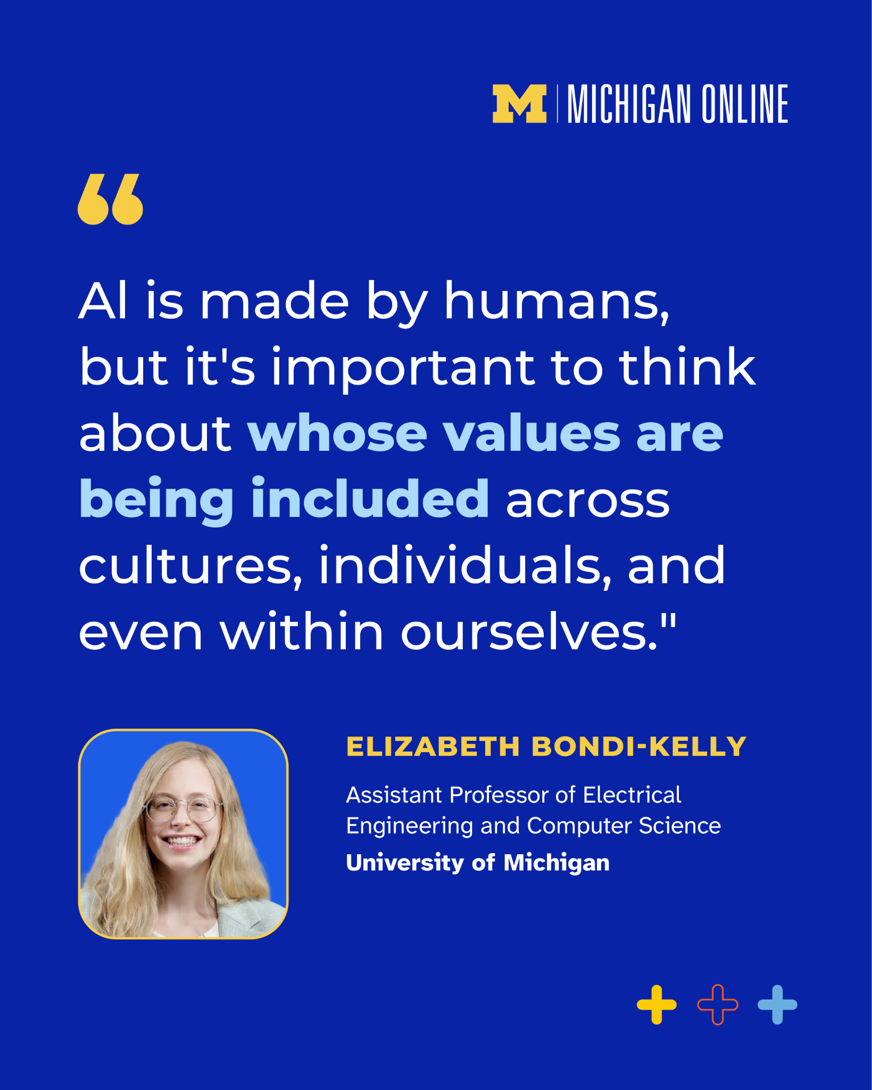

(Click images for downloadable assets)

Alt Text Primary Image: A quote card discussing ethical issues in AI, emphasizing power, participation, and whether AI should be used in certain situations. The quote is attributed to Elizabeth Bondi-Kelly, shown in a small portrait, with her title as Assistant Professor at the University of Michigan and Michigan Online branding at the bottom.

Alt Text Secondary Image: A quote card stating that AI is created by humans and raises questions about whose values are represented across cultures and individuals. The quote is attributed to Elizabeth Bondi-Kelly, shown in a small portrait, with her title at the University of Michigan and Michigan Online branding.

Post 3- Graphic Image Post:

Post Copy:
Learn how to integrate AI effectively, with a focus on community.

In the “Realizing AI for Social Impact” series, you’ll learn to connect the dots between:
- Real-world challenges and AI methods
- Technical decisions and ethical consequences
- Innovation and accountability

CTA: Join us today and learn to develop ethical and inclusive AI solutions for the future.

Hashtags: #AIForGood #SocialImpact #EthicalAI

URL: https://myumi.ch/RQ1w9

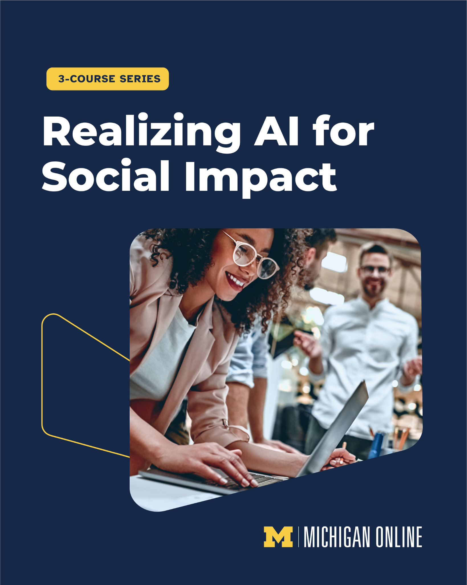

(Click image for downloadable asset)

Alt Text: Dark blue promotional graphic advertising a “3-Course Series” called “Realizing AI for Social Impact.” Below the large white title is a photo of a smiling woman with curly hair and glasses typing on a laptop while collaborating with coworkers in an office setting. The Michigan Online logo appears at the bottom right.

Post 4 - Vertical Reel

Post Copy:
AI is already shaping social impact; are you shaping how AI is implemented?

“Realizing AI for Social Impact” is designed for practitioners navigating real-world applications, technologists who want to build responsibly, and anyone looking for a deeper understanding of AI’s practical uses in their lives and careers.

CTA: Learn actionable frameworks and gain real-world perspective. Start today.

Hashtags: #AIForGood #SocialImpact #EthicalAI

URL: https://myumi.ch/RQ1w9

Vertical Reel 1: Post Thumbnail:
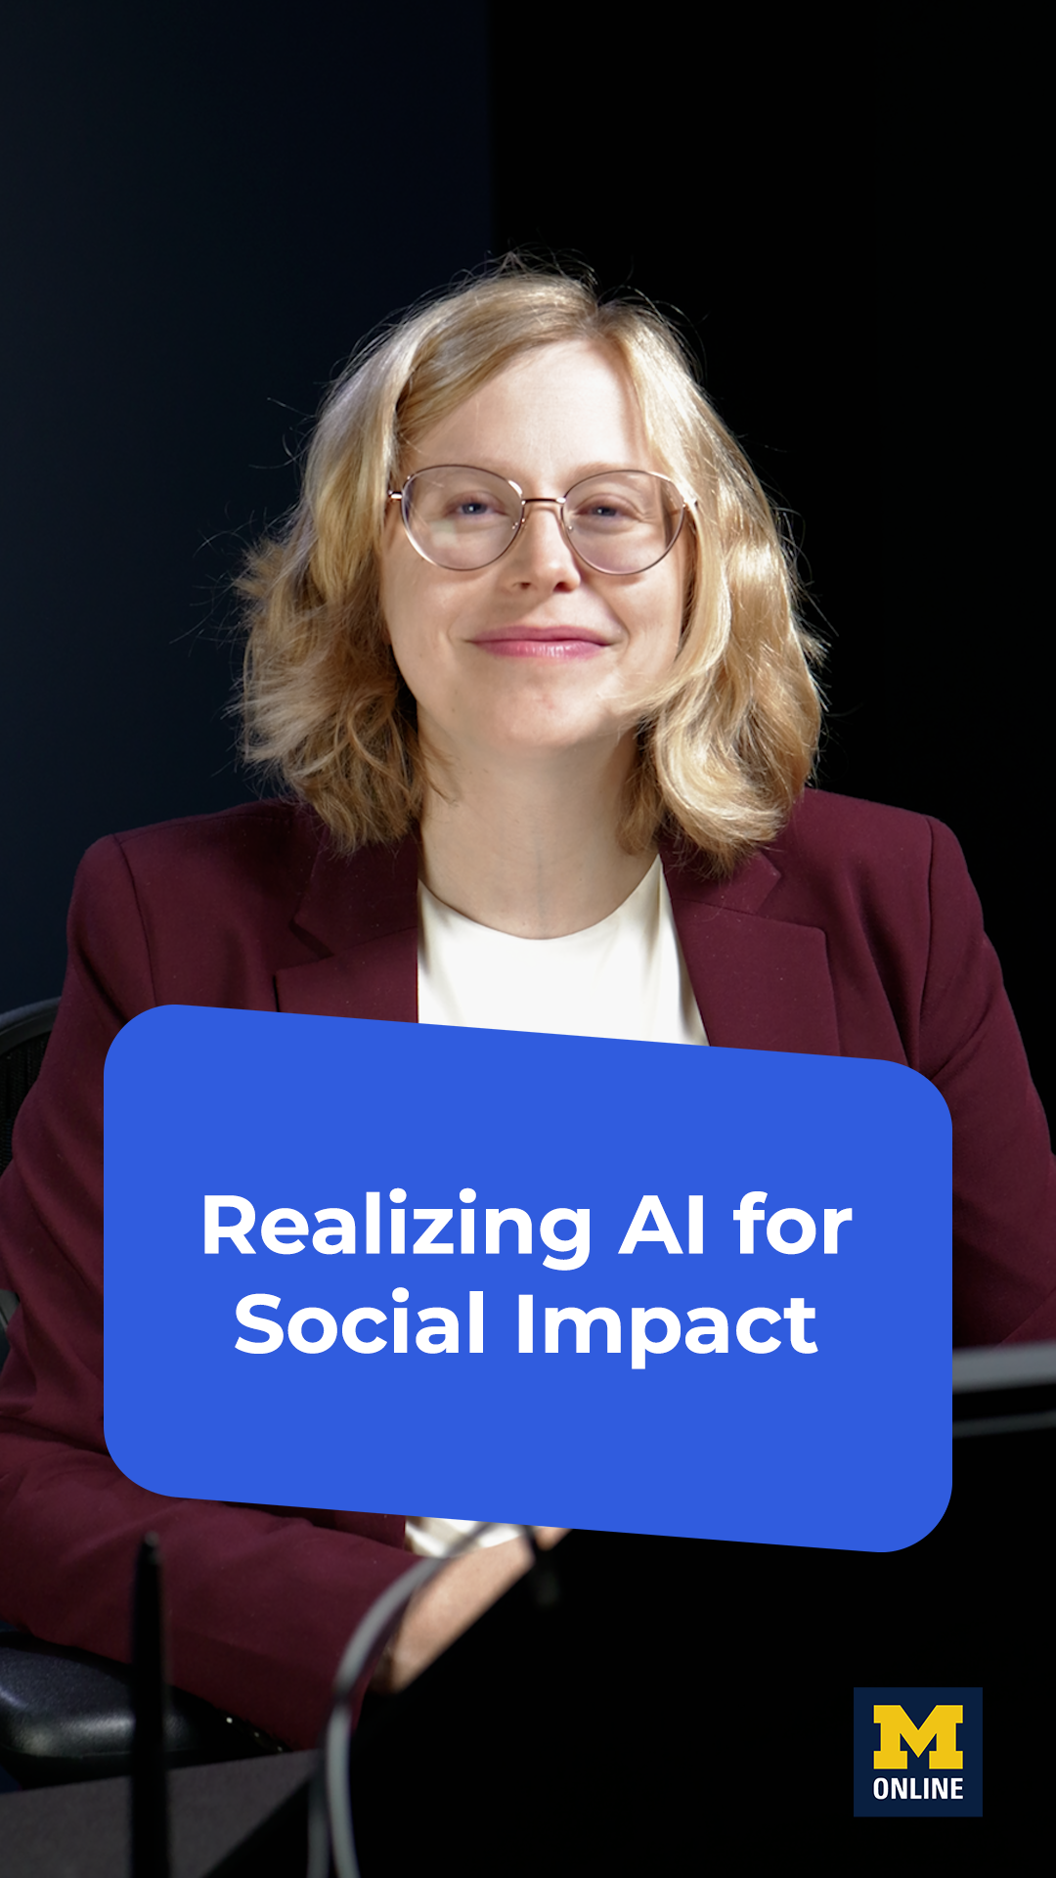

(Click images for downloadable assets)

