About This Toolkit
This Social Media Toolkit makes it easy to share “Climate Solutions” content across your social channels. On the following pages, you’ll find ready-to-post graphics and/or videos, copy, and URL links designed for usage across Facebook, Instagram, LinkedIn, and X. Feel free to edit the post copy to fit your voice across your accounts.

We’d love it if you tagged us!

Facebook- @MichiganOnline
Instagram- @michigan.online
LinkedIn- @Michigan Online

Series Graphic:


(Click image for downloadable asset)

Alt Text: Two open hands cradle a floating globe showing North and South America against a white background.

Individual Course Graphics:

Alt Text Image 1: A smiling man in safari clothing holds binoculars while standing in a dry, wooded landscape with a rhinoceros behind him.

Alt Text Image 2: A handmade protest sign reads, “THERE IS NO PLANET B,” held above a crowd at an outdoor demonstration.

Alt Text Image 3: Two hands hold a small green plant and a handful of dark soil.

Course 1 Course 2
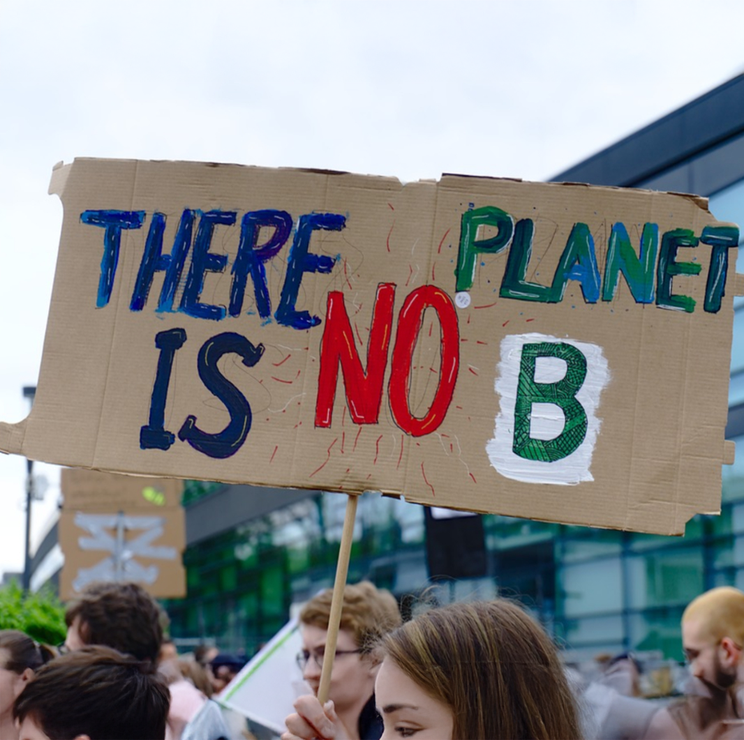
Course 3


(Click image for downloadable asset)

Post 1- Course Graphic Carousel:

Post Copy: Climate change and sustainability are among the defining challenges of our time. As these issues continue to evolve, learn how to move beyond traditional approaches and develop innovative, equitable, and community-centered climate solutions.

In our newest online course series, “Climate Solutions,” you’ll gain the skills to create lasting environmental impact while strengthening communities.

CTA: Explore the series through Michigan Online.

Hashtags: #ClimateSolutions #ClimateAction #Sustainability

URL: https://myumi.ch/www5A

Slide 1 Slide 2
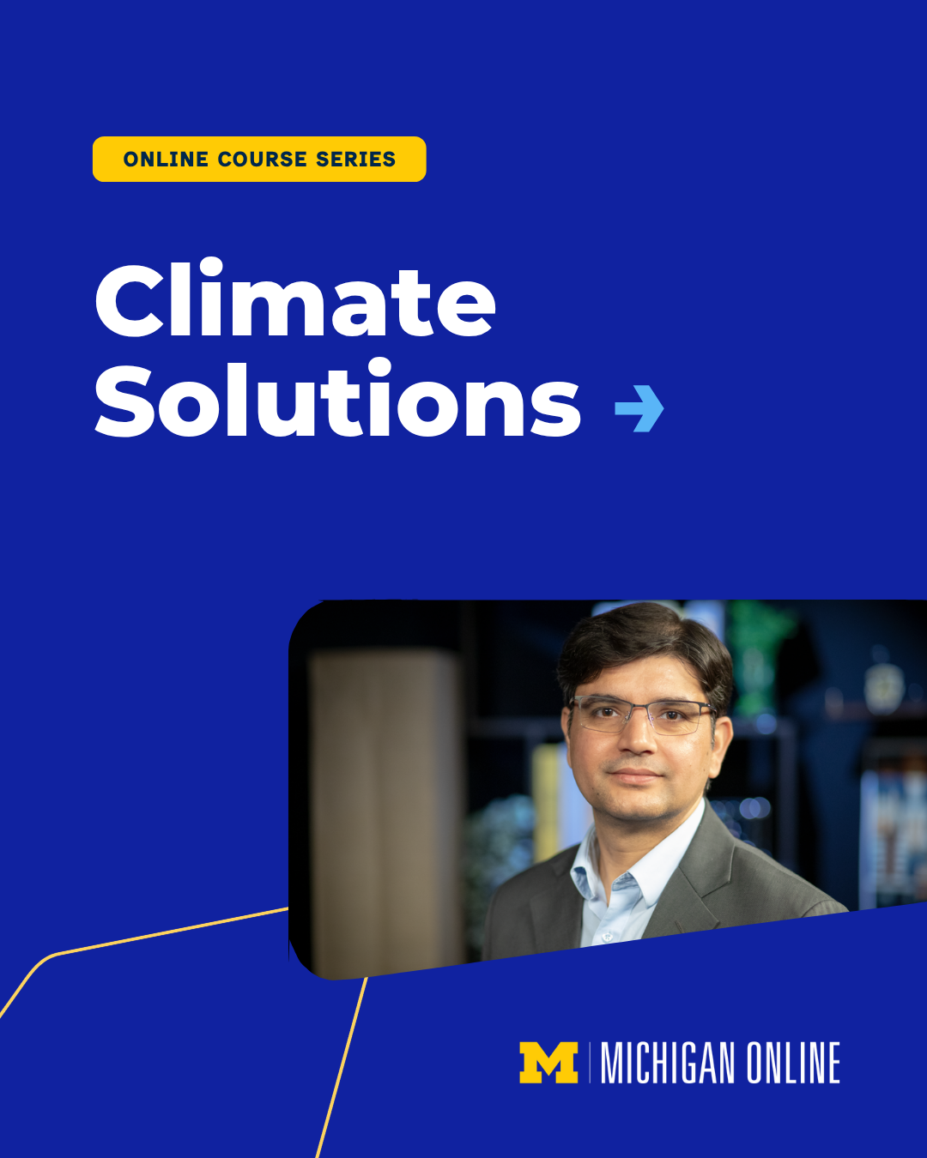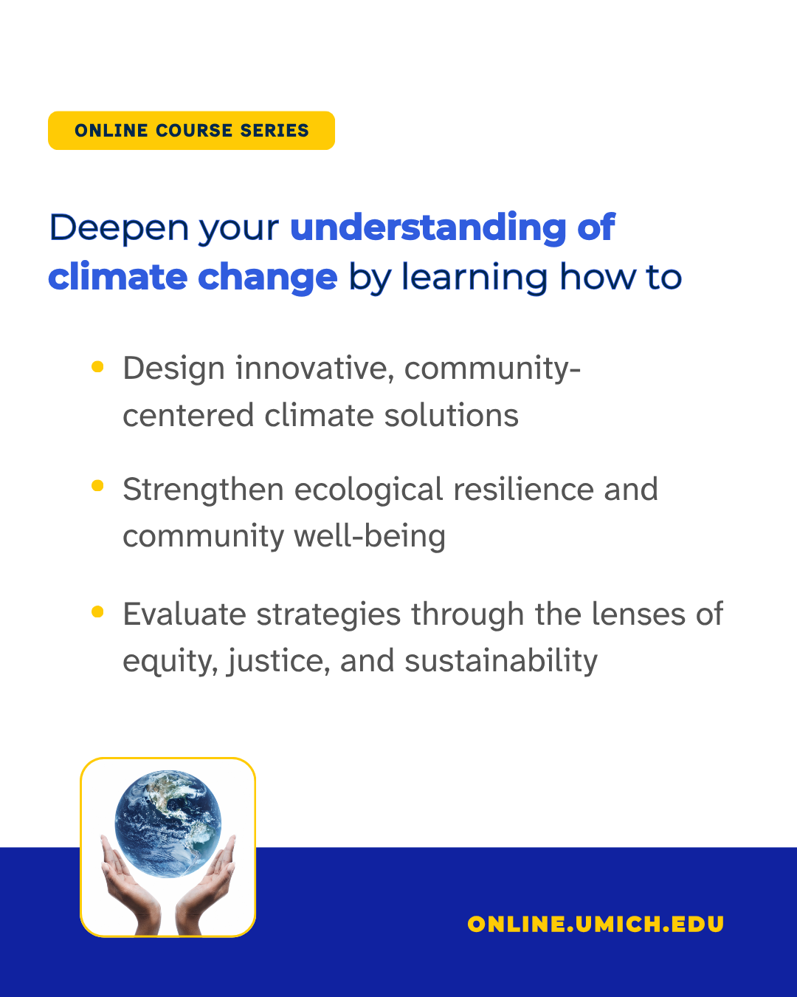

Slide 3 Slide 4
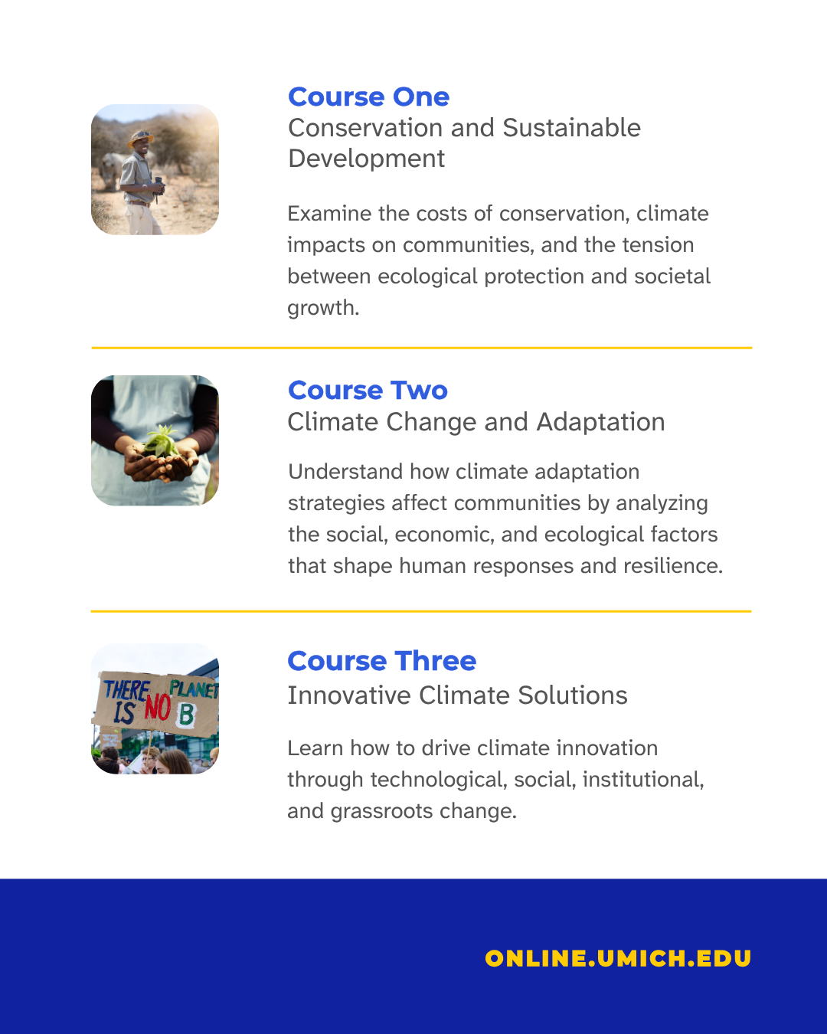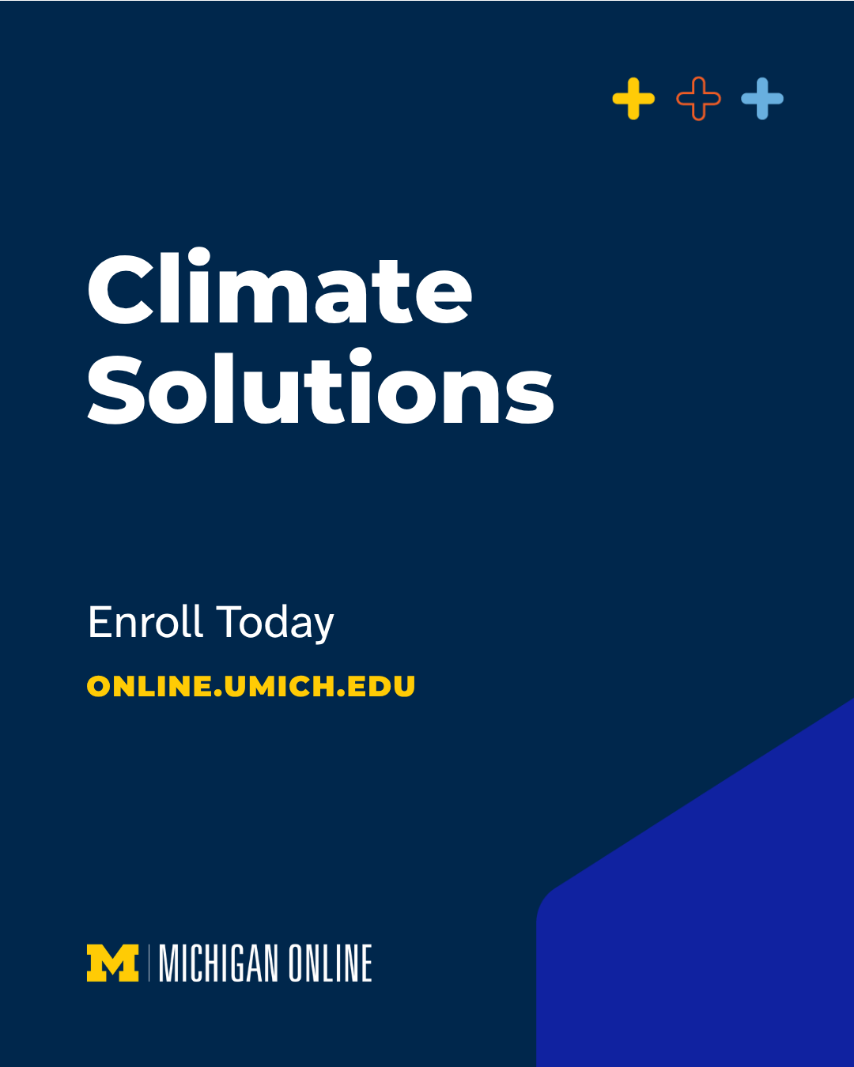

(Click image for downloadable asset)

Course Graphic Carousel Alt Text:

Alt Text Slide 1: Blue graphic for a Michigan Online course series titled “Climate Solutions,” featuring a portrait of an instructor wearing glasses and a suit jacket.

Alt Text Slide 2: Michigan Online course graphic highlighting three learning goals for understanding climate change: designing community-centered solutions, strengthening ecological resilience, and evaluating strategies through equity, justice, and sustainability. A small graphic at the bottom shows the Earth held between two hands.

Alt Text Slide 3: Michigan Online graphic outlining three courses in a climate solutions series: Conservation and Sustainable Development, Climate Change and Adaptation, and Innovative Climate Solutions.

Alt Text Slide 4: Dark blue Michigan Online graphic for “Climate Solutions” with a call to enroll at online.umich.edu.

Post 2 - Quote Graphics:

Post Copy: The impact of climate innovation reaches far beyond today.

In the “Climate Solutions” series, @University of Michigan- School for Environment and Sustainability lecturer @Rajiv Ghimire explores innovative approaches to building lasting climate solutions in a changing world.

CTA: Explore the “Climate Solutions” course series on Michigan Online:

Hashtags: #ClimateSolutions #ClimateAction #Sustainability

URL: https://myumi.ch/www5A

Primary Image: Secondary Image:

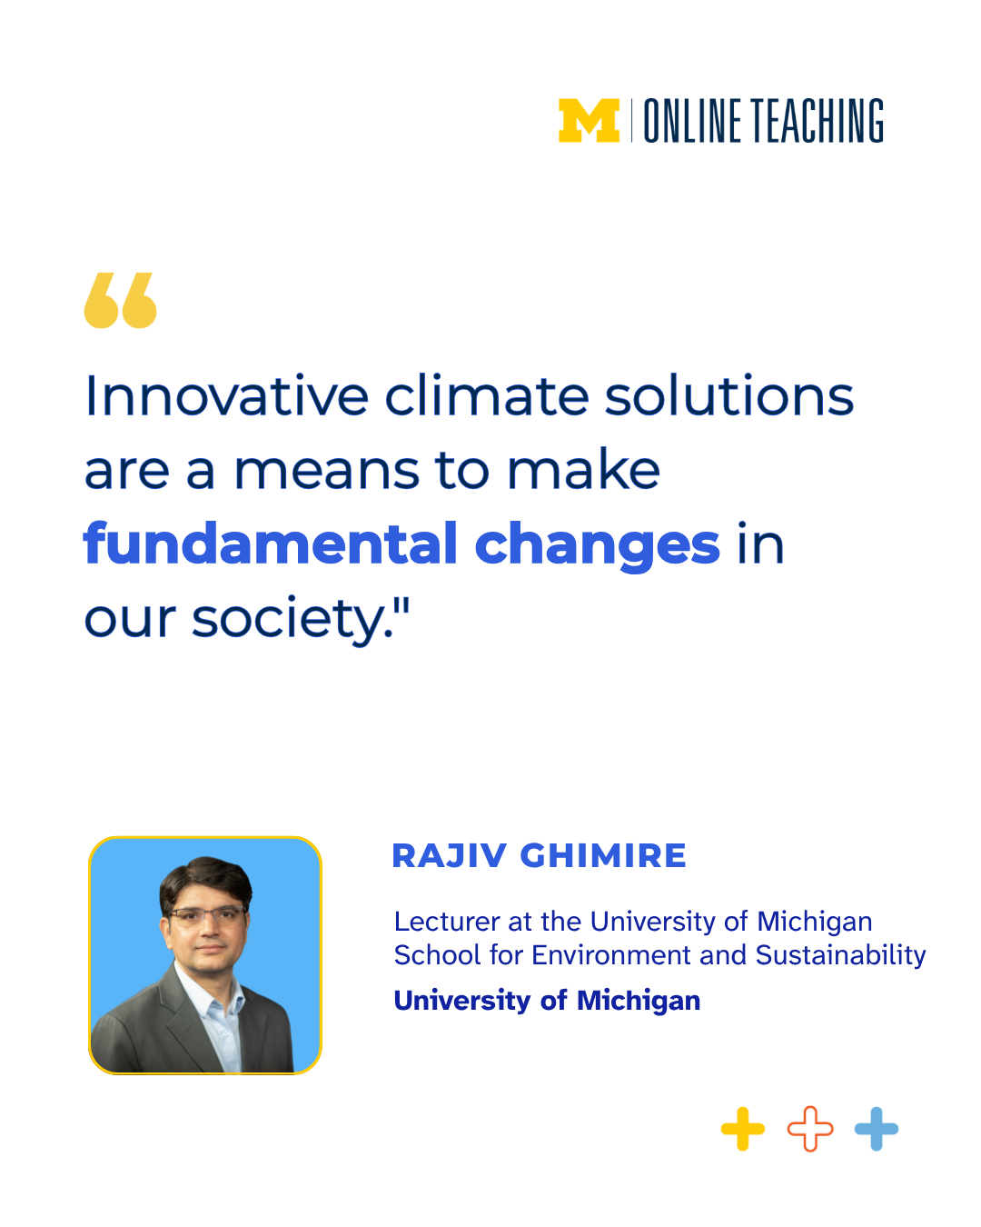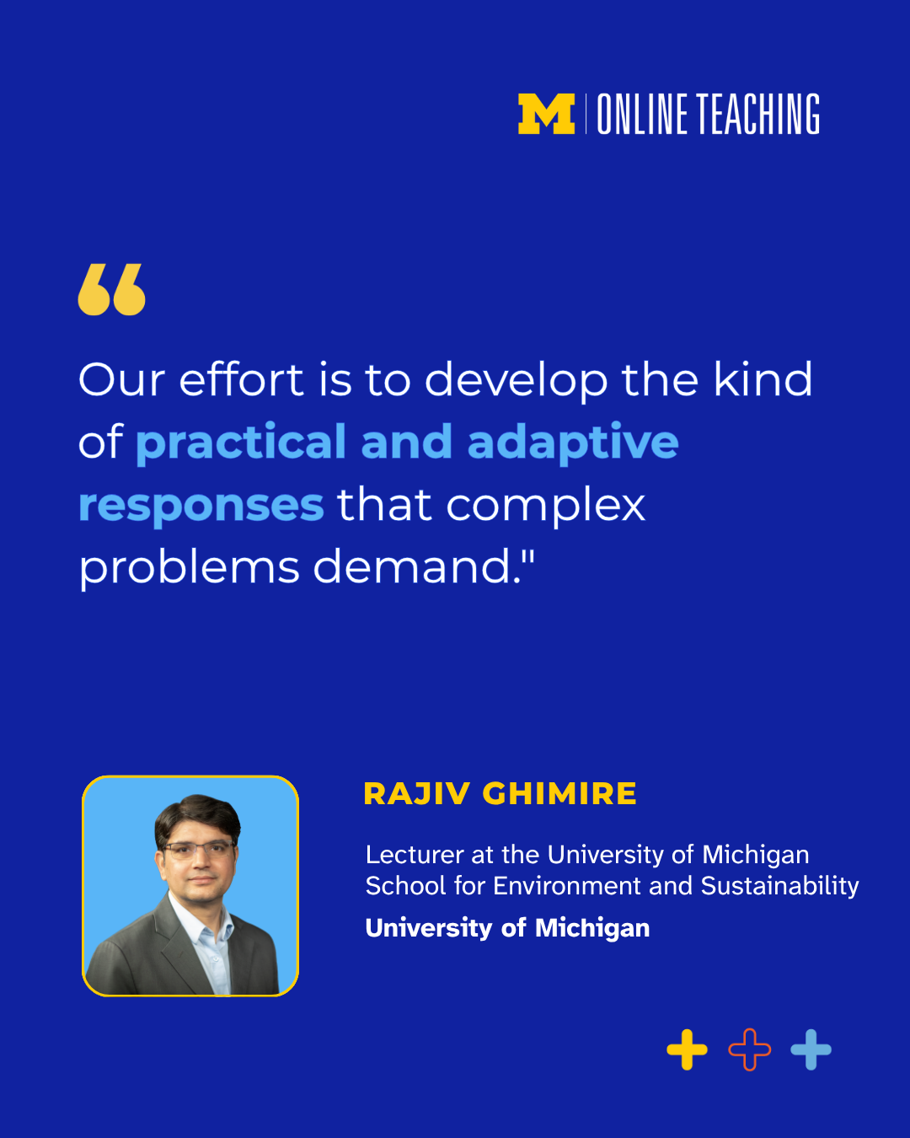

(Click image for downloadable asset)

Alt Text Primary Image: Michigan Online graphic featuring a quote from Rajiv Ghimire from the School for Environment and Sustainability: “Innovative climate solutions are a means to make fundamental changes in our society.”

Alt Text Secondary Image: Michigan Online graphic featuring Rajiv Ghimire’s quote: “Our effort is to develop the kind of practical and adaptive responses that complex problems demand.” Ghimire is identified as a lecturer at the University of Michigan School for Environment and Sustainability.

Post 3- Graphic Image Post

Post Copy: Climate challenges are maturing, and so are the solutions needed to address them.

Explore innovative approaches to addressing climate challenges, from sustainable practices and environmental strategies to the systems shaping our future.

In the three-course “Climate Solutions” series, you’ll learn how to:
🌍 Design innovative, community-centered climate solutions
🌍 Strengthen ecological resilience and community well-being
🌍 Evaluate climate strategies through the lenses of equity, justice, and sustainability

CTA: Deepen your understanding of climate change with Michigan Online.

Hashtags: #ClimateSolutions #ClimateAction #Sustainability

URL: https://myumi.ch/www5A

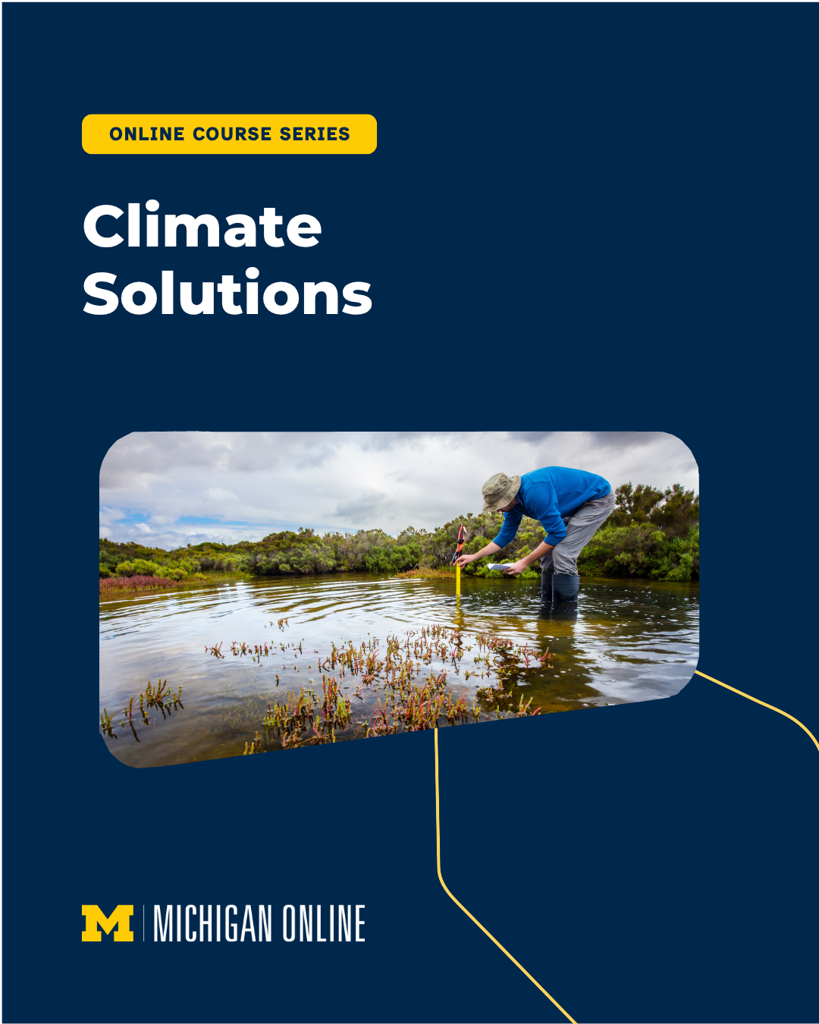

(Click image for downloadable asset)

Alt Text: Michigan Online graphic for the “Climate Solutions” online course series, featuring a researcher collecting data while standing in shallow water.

Post 4 - Promotional Video Reel

Post Copy: Join @University of Michigan- School for Environment and Sustainability lecturer @Rajiv Ghimire in “Climate Solutions,” a new online course series exploring community-led approaches to climate change shaped by environmental science, policy, and lived experience.

CTA: Build the knowledge and tools to take action where you are. Enroll on Michigan Online.

Hashtags: #ClimateSolutions #ClimateAction #Sustainability

URL: https://myumi.ch/www5A

Promo Video Optional Post Thumbnail:
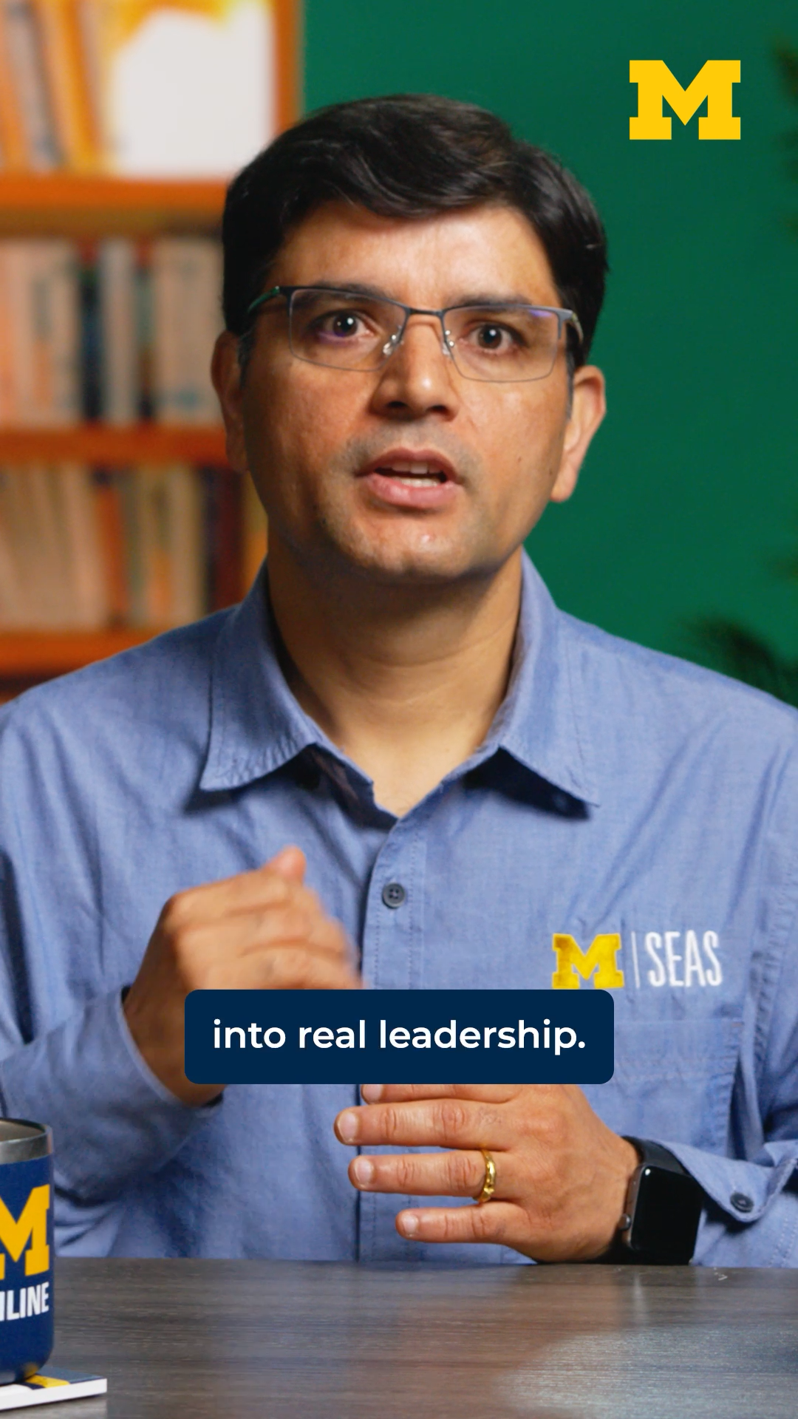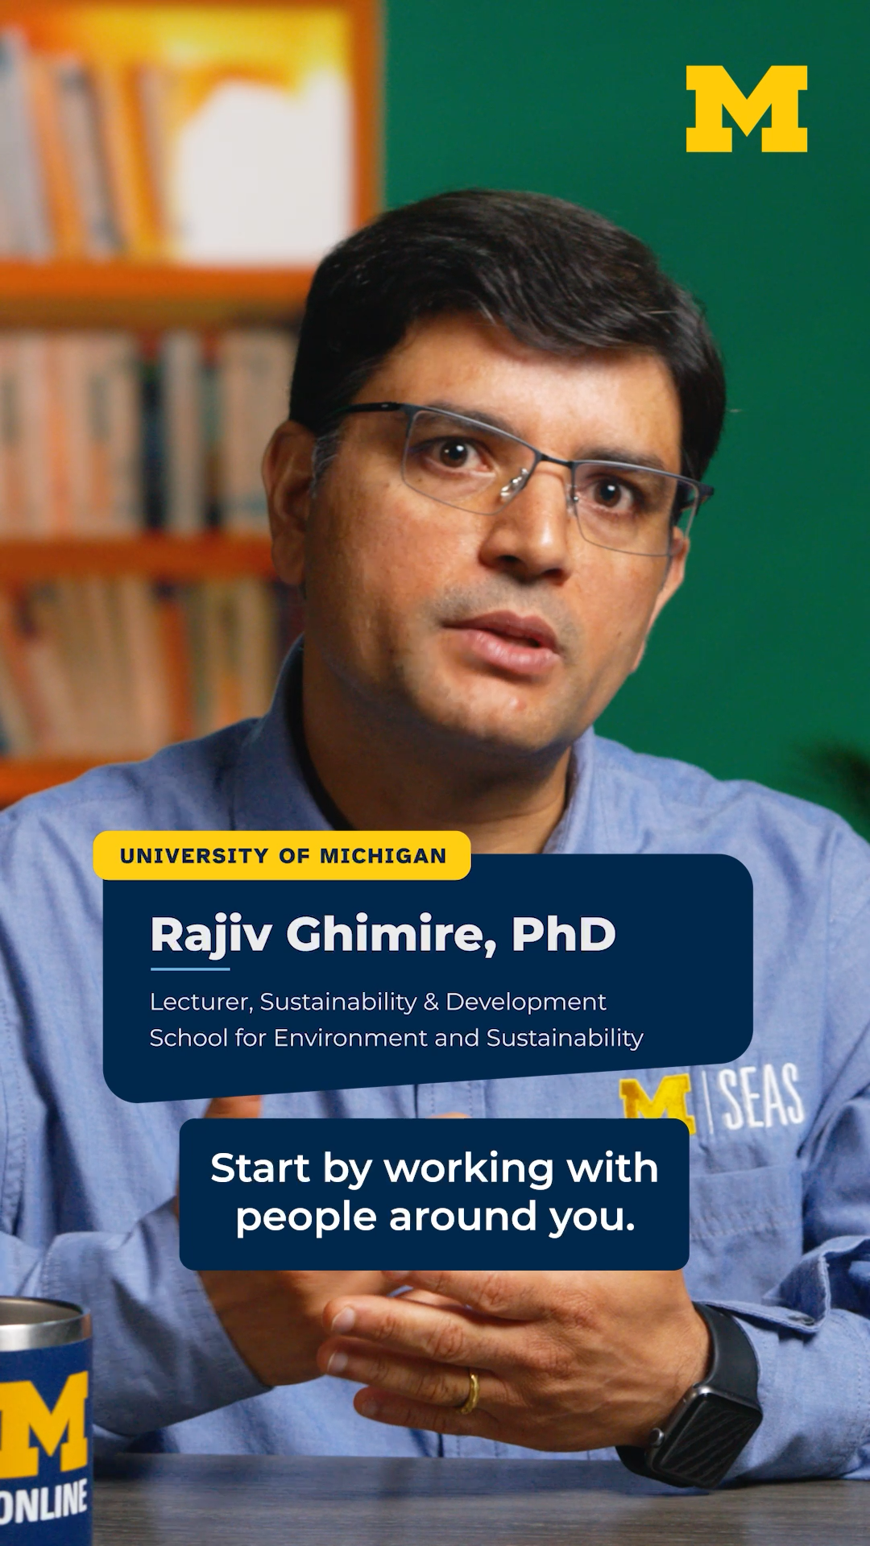

(Click images for downloadable assets)

Post 5 - Vertical Reel 1

Post Copy: Climate change has no shortage of daunting statistics, but that’s only half the story.

Never before have we had such an abundance of knowledge, tools, and people working across disciplines and borders on climate change. The “Climate Solutions” online course series from Michigan Online brings together perspectives from around the world to explore our most pressing challenges and the solutions already within our reach.

CTA: Explore “Climate Solutions” on Michigan Online.

Hashtags: #ClimateSolutions #ClimateAction #Sustainability

URL: https://myumi.ch/www5A

Vertical Reel 1: Optional Post Thumbnail:


(Click images for downloadable assets)

Post 6 - Vertical Reel 2

Post Copy: When we picture a climate solution, it’s easy to picture something big: a technological breakthrough, a major institution, a sweeping new idea.

But much of the most important work is happening in local communities and grassroots organizations around the world.

CTA: Explore those possibilities in our newest online course series, “Climate Solutions.”

Hashtags: #ClimateSolutions #ClimateAction #Sustainability

URL: https://myumi.ch/www5A

Vertical Reel 2 Optional Post Thumbnail:


(Click images for downloadable assets)

Post 7 - Vertical Reel 3

Post Copy: Our newest online course series, “Climate Solutions,” with @University of Michigan- School for Environment and Sustainability lecturer @Rajiv Ghimire, looks at communities around the world, the climate challenges they are facing, and the solutions emerging from their experiences.

CTA: See how global communities are shaping climate solutions. Explore the series on Michigan Online.

Hashtags: #ClimateSolutions #ClimateAction #Sustainability

URL: https://myumi.ch/www5A

Vertical Reel 3 Optional Post Thumbnail:
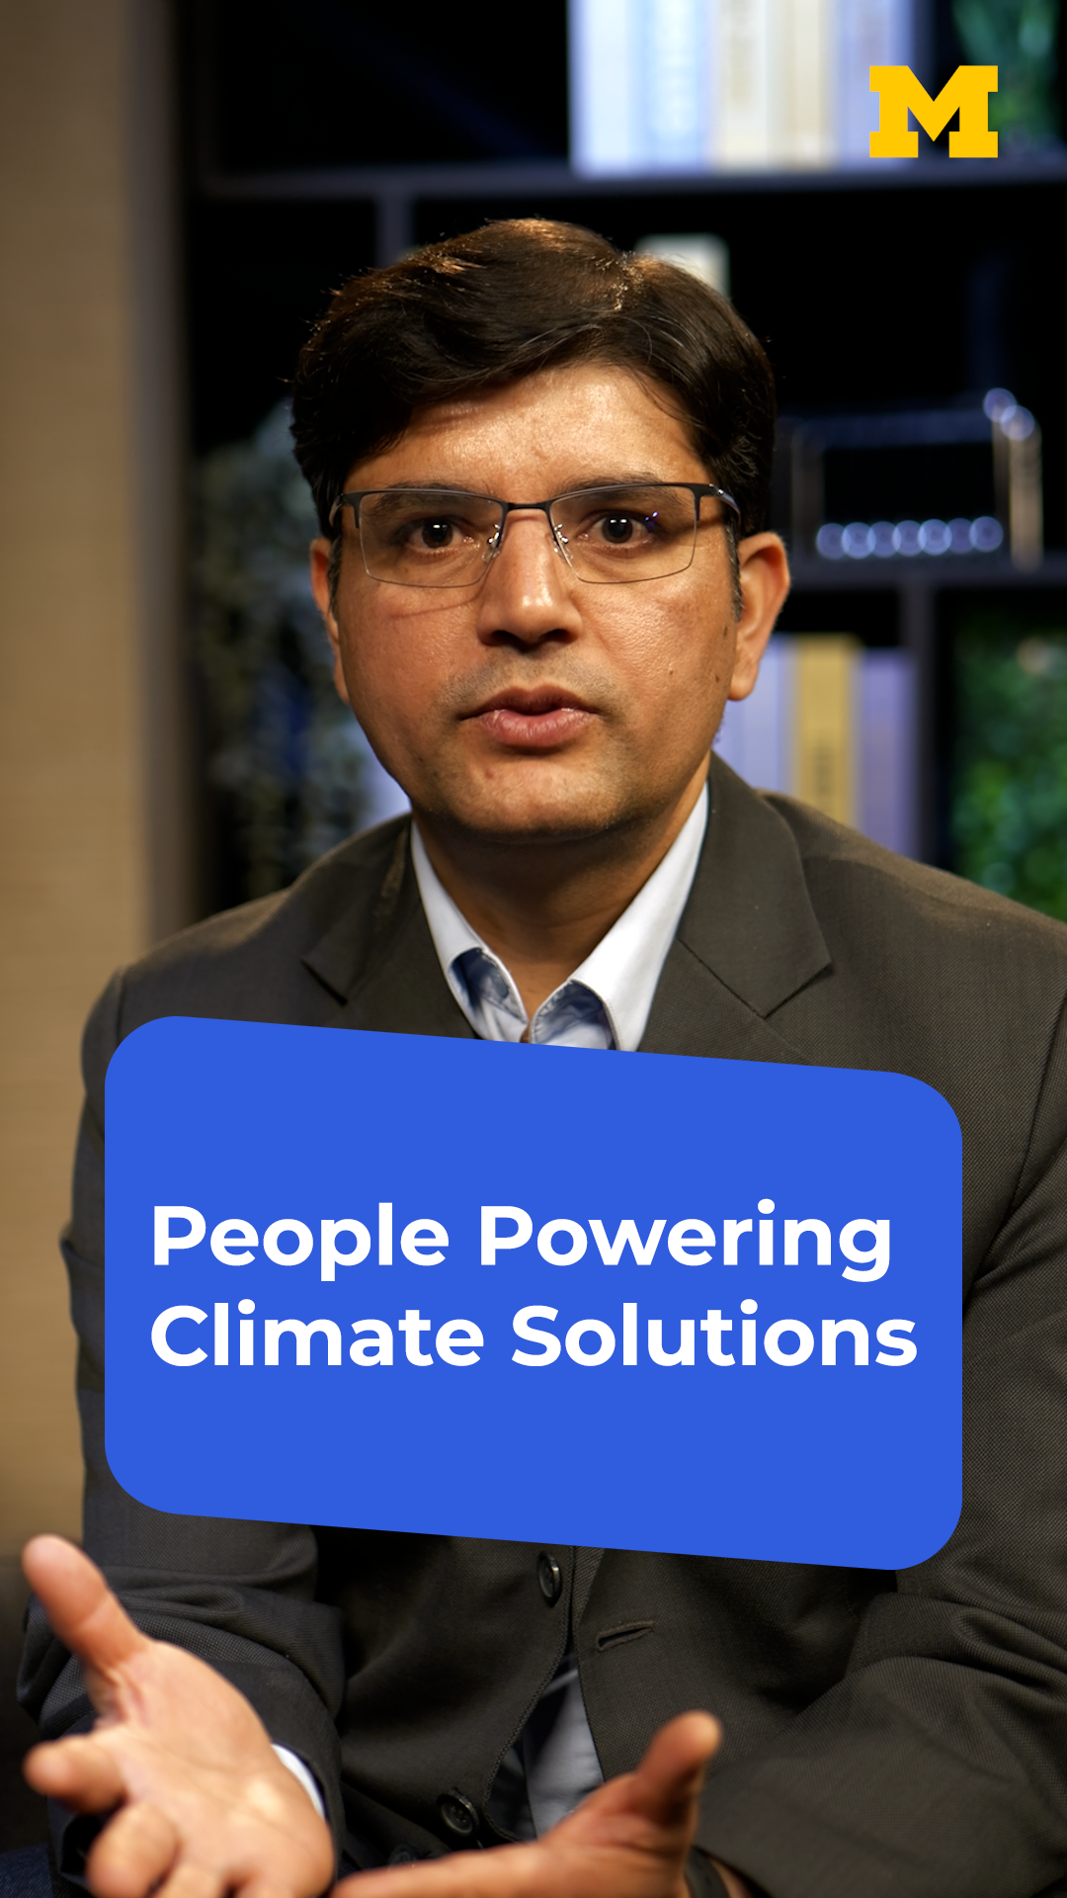

(Click images for downloadable assets)

