About This Toolkit
This Social Media Toolkit makes it easy to share “Practical JavaScript: From Scratch to React” content across your social channels. On the following pages, you’ll find ready-to-post graphics and/or videos, copy, and URL links designed for usage across Facebook, Instagram, LinkedIn, and X. Feel free to edit the post copy to fit your voice across your accounts.

We’d love it if you tagged us!

Facebook- @MichiganOnline
Instagram- @michigan.online
LinkedIn- @Michigan Online

Series or Course Graphic:


(Click image for downloadable asset)

Alt Text: A yellow JavaScript icon, a shield with the letters JS in the middle, on top of a dark blue background that includes code, webpages, and other graphics to relay web page development.

Individual Course Graphics:

Alt Text Image 1: A yellow JavaScript icon, a shield with the letters JS in the middle, on top of a purple background that includes code, webpages, and other graphics to relay web page development.

Alt Text Image 2: A yellow JavaScript icon, a shield with the letters JS in the middle, on top of a light blue background that includes code, webpages, and other graphics to relay web page development.

Alt Text Image 3: A yellow JavaScript icon, a shield with the letters JS in the middle, on top of a red background that includes code, webpages, and other graphics to relay web page development.

Alt Text Image 4: A yellow JavaScript icon, a shield with the letters JS in the middle, on top of a dark purple background that includes code, webpages, and other graphics to relay web page development.

Course 1 Course 2
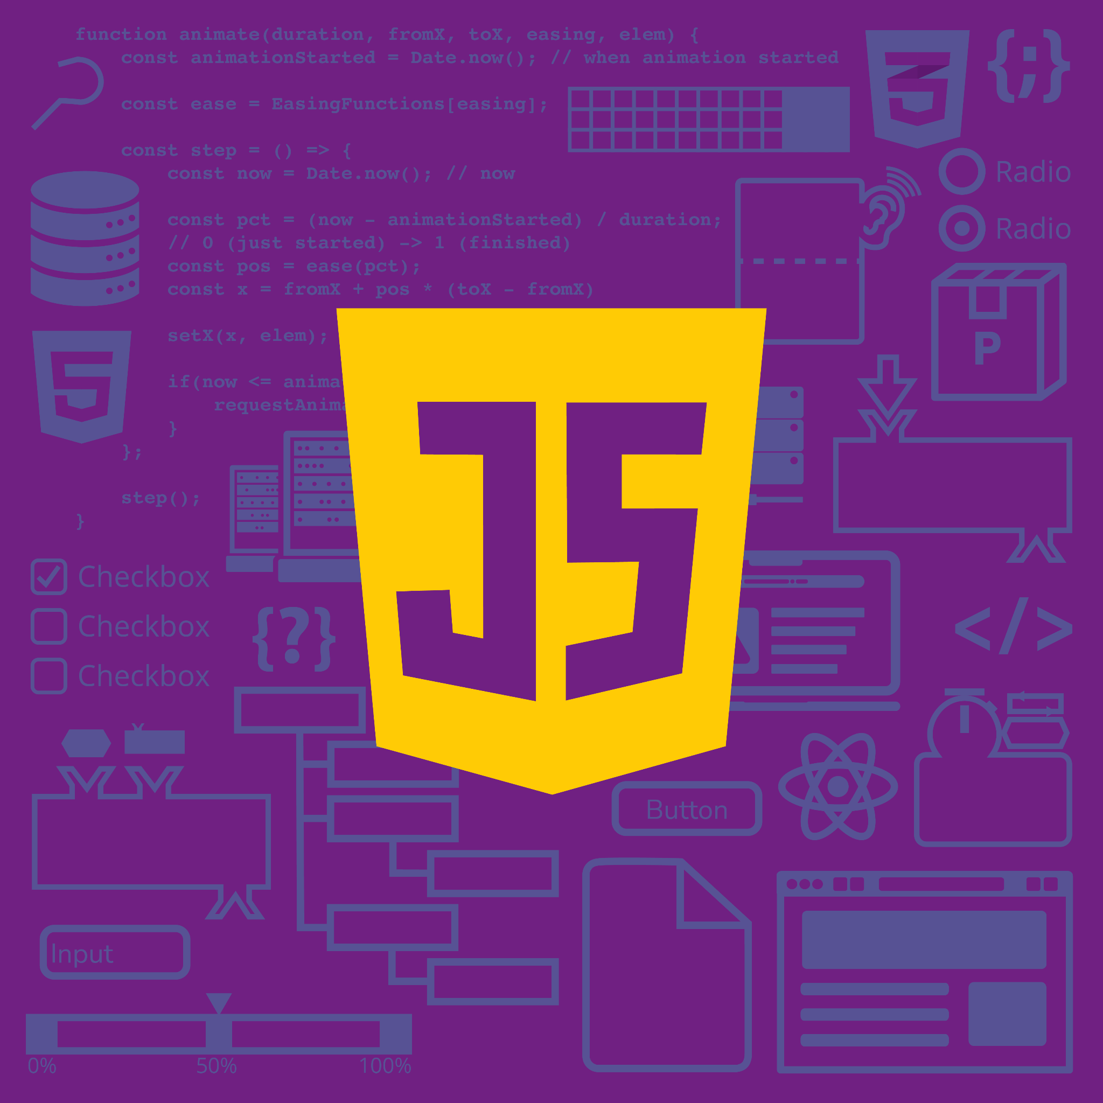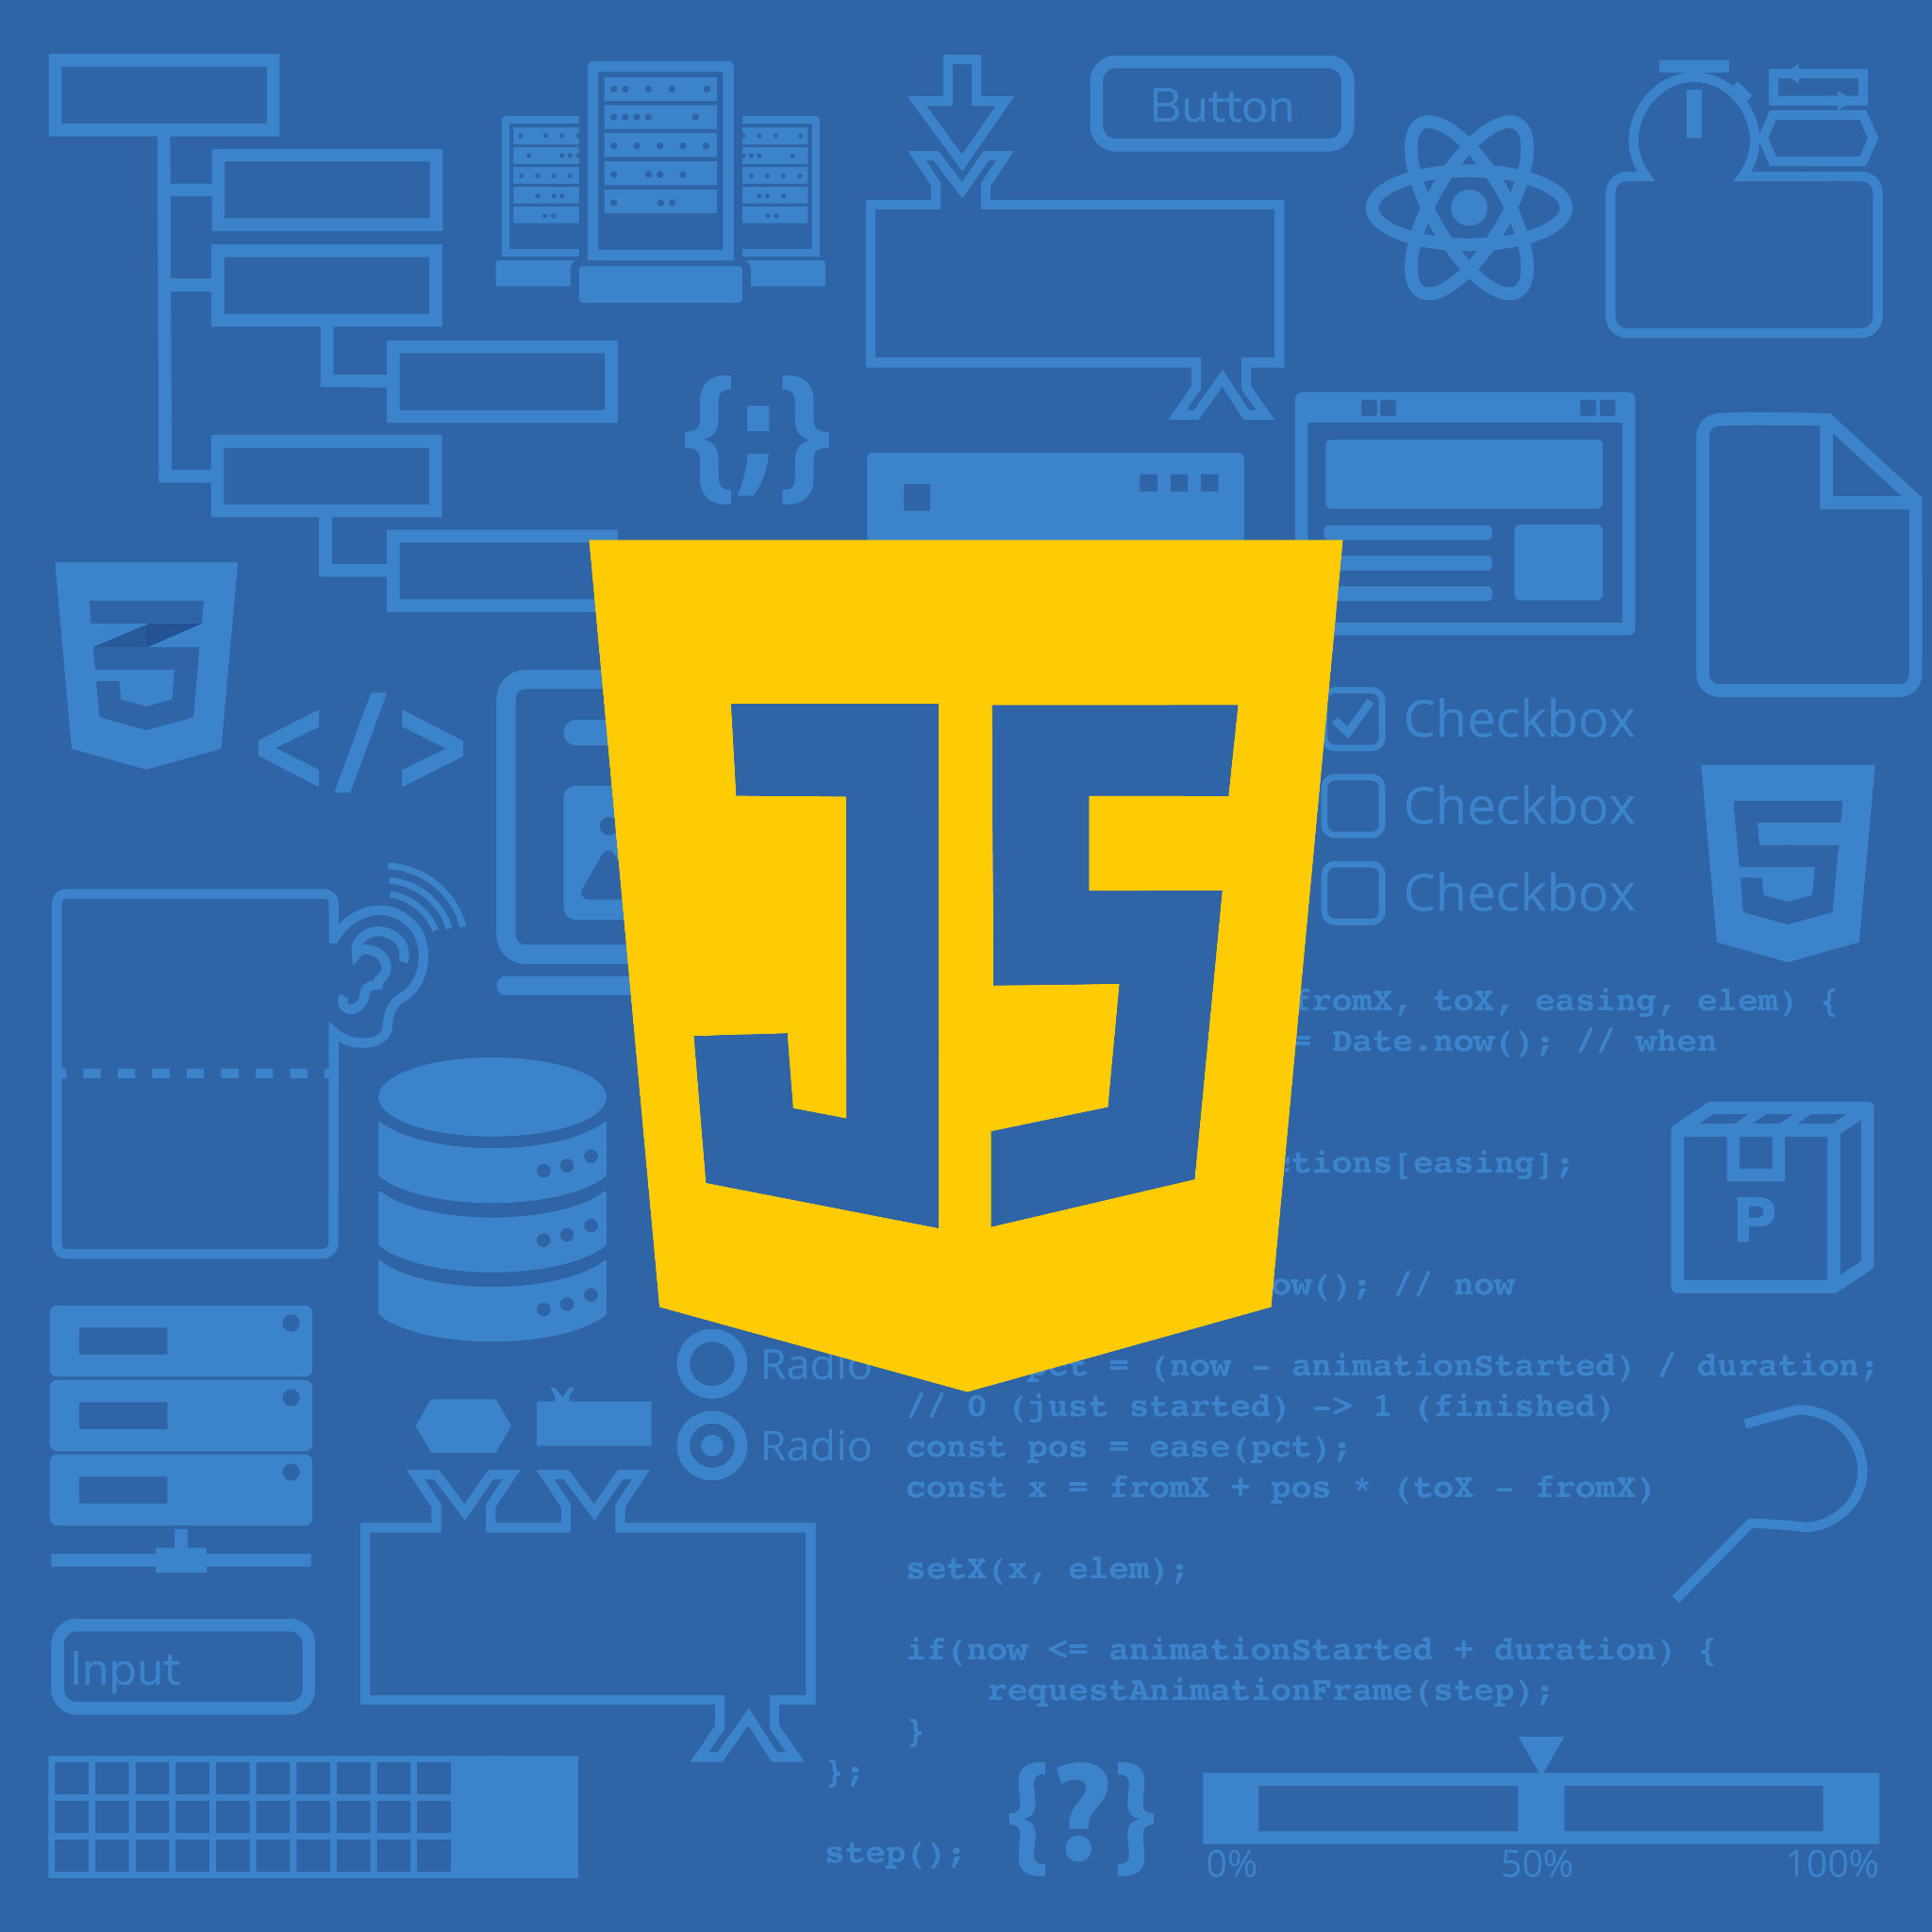
Course 3 Course 4


(Click images for downloadable assets)

Post 1 - Course Graphic Carousel:

Post Copy: Web development moves quickly. Build the JavaScript skills to keep pace.

Our newest online course series, “Practical JavaScript: From Scratch to React,” takes learners from JavaScript fundamentals to developing interactive, full-stack web applications with React, one of today’s most in-demand JavaScript frameworks. Through hands-on projects, learners build the skills to create production-ready web applications with confidence.

CTA: Explore the series through Michigan Online.

Hashtags: #JavaScript #WebDevelopment #ReactJS #Programming

URL: https://myumi.ch/pgVry

Slide 1 Slide 2
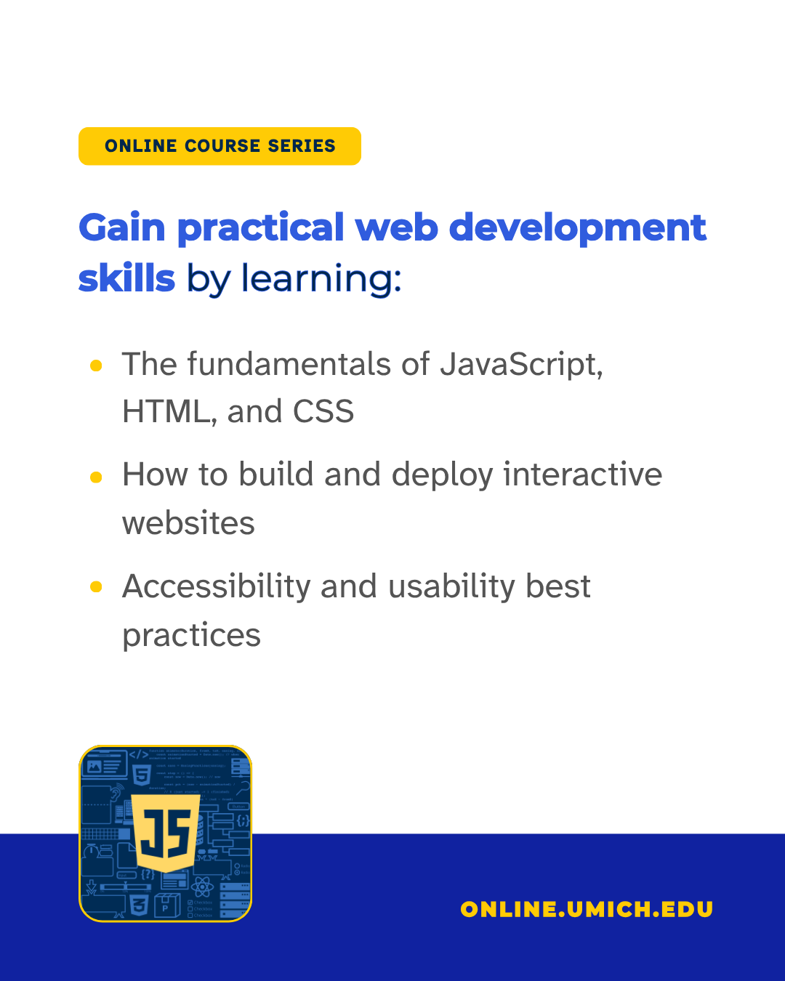

Slide 3 Slide 4
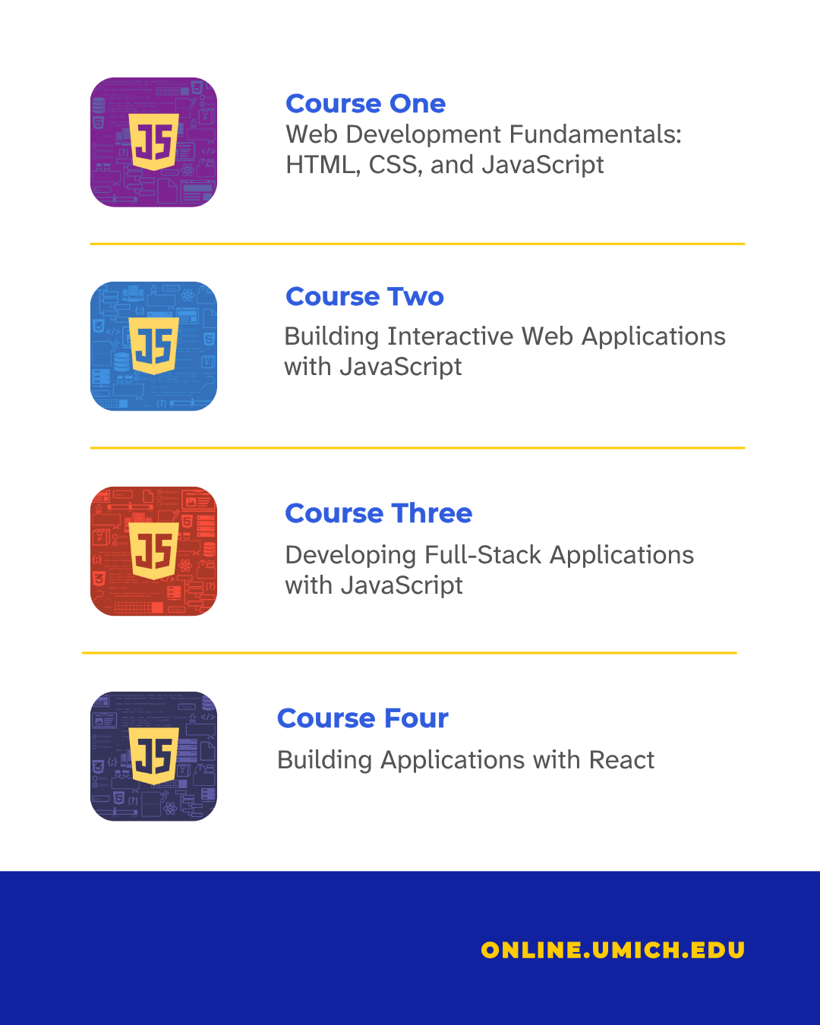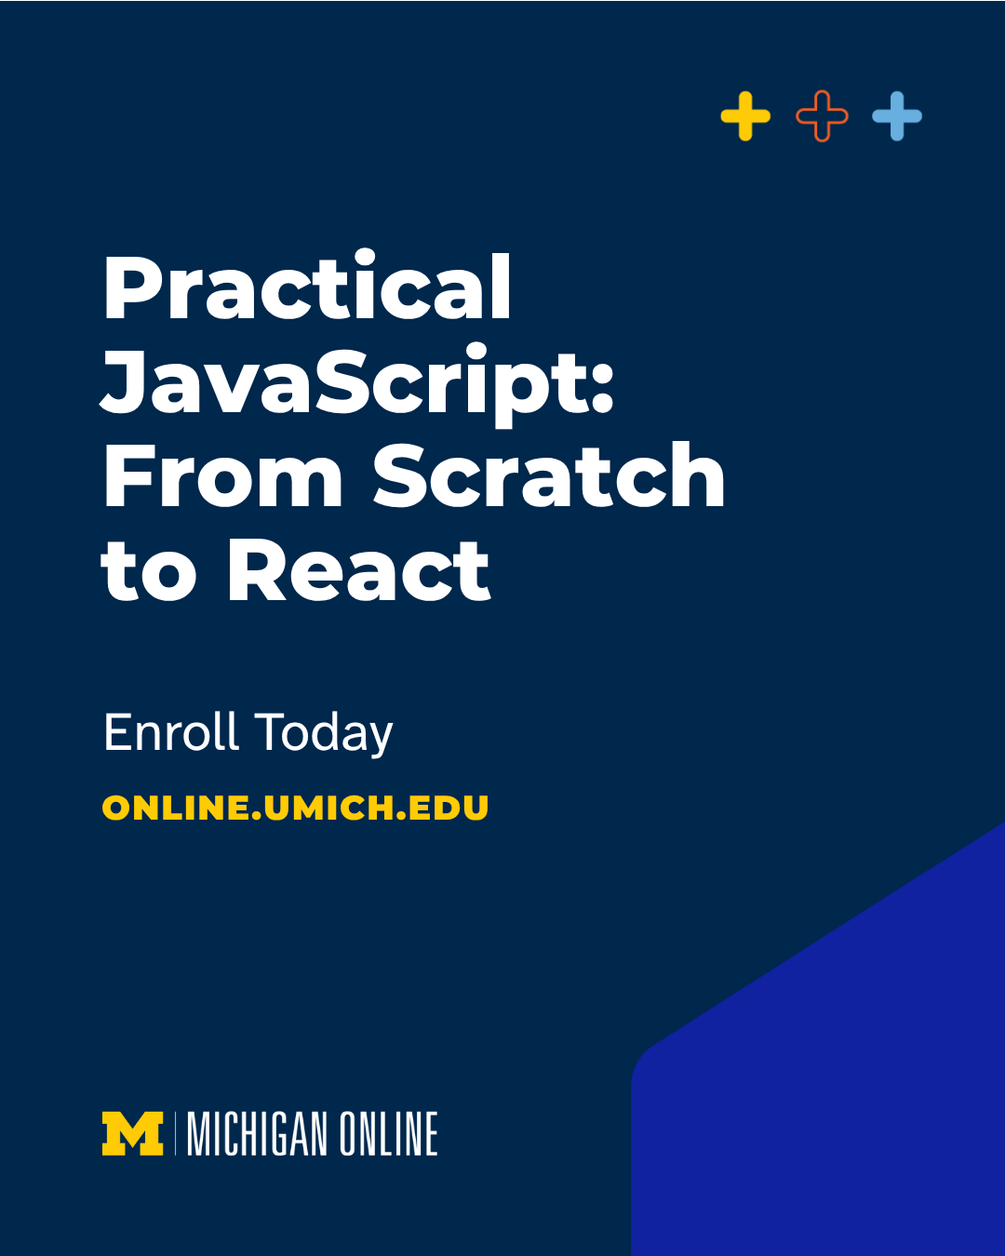

(Click images for downloadable assets)

Course Graphic Carousel Alt Text:

Alt Text Slide 1: Promotional graphic for a University of Michigan Online course series titled "Practical JavaScript: From Scratch to React," featuring a smiling person in a portrait against a blue background with Michigan Online branding.

Alt Text Slide 2: Promotional graphic for the University of Michigan Online course series. A heading reads, "Gain practical web development skills by learning:" followed by bullet points covering JavaScript, HTML, CSS, building and deploying interactive websites, and accessibility and usability best practices. A JavaScript logo appears near the bottom, with "ONLINE.UMICH.EDU" displayed on a blue footer.

Alt Text Slide 3: Promotional graphic outlining four courses in a University of Michigan Online web development series. The courses are: Web Development Fundamentals: HTML, CSS, and JavaScript; Building Interactive Web Applications with JavaScript; Developing Full-Stack Applications with JavaScript; and Building Applications with React. Each course is paired with a differently colored JavaScript-themed icon, and "ONLINE.UMICH.EDU" appears in a blue footer.

Alt Text Slide 4: Promotional graphic for the University of Michigan Online course series "Practical JavaScript: From Scratch to React" with a call to enroll and the website online.umich.edu.

Post 2 - Quote Graphic(s):

Post Copy: With JavaScript, the possibilities are endless.

In the “Practical JavaScript: From Scratch to React” series, @umschoolofinformation associate professor Steve Oney explores the fundamentals of JavaScript and how to build code with confidence.

CTA: Build the skills to create modern web applications.

Hashtags: #JavaScript #WebDevelopment #ReactJS #Programming

URL: https://myumi.ch/pgVry

Primary Image: Secondary Image:

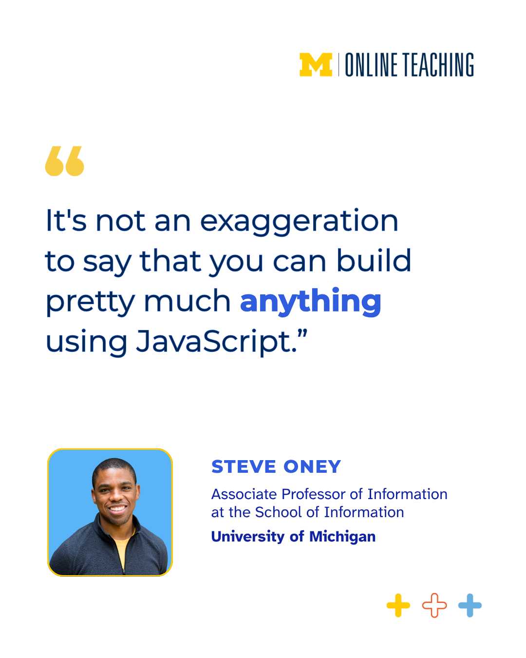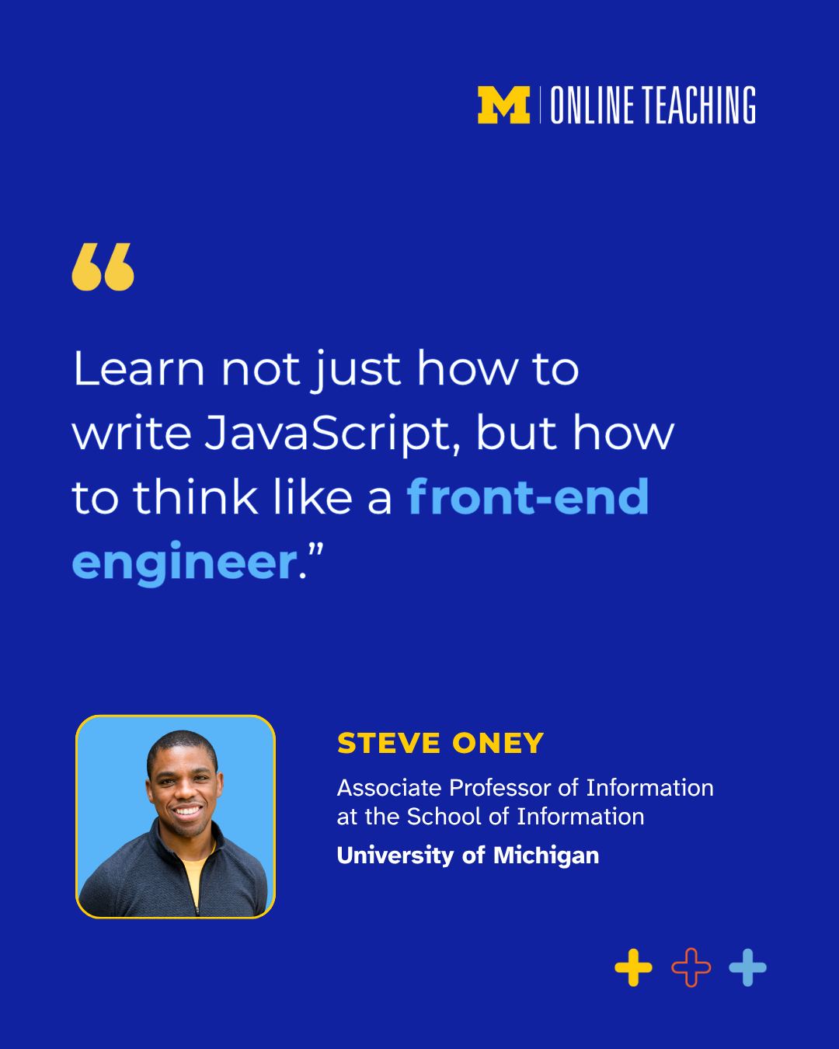

(Click image for downloadable asset)

Alt Text Primary Image: Under the Michigan Online logo, a featured quote reads, "It's not an exaggeration to say that you can build pretty much anything using JavaScript." Below is a headshot of Steve Oney, Associate Professor of Information at the School of Information, University of Michigan.

Alt Text Secondary Image: Under the Michigan Online logo, a featured quote reads, "Learn not just how to write JavaScript, but how to think like a front-end engineer." A headshot of Steve Oney, Associate Professor of Information at the School of Information, University of Michigan.

Post 3 - Graphic Image Post

Post Copy: From the websites we visit to the apps we use, coding is at the center of it all. Learn the skills to create one yourself.
Explore the foundations of modern web development, from writing your first lines of JavaScript to creating interactive, full-stack applications with today’s most in-demand tools.
In the four-course “Practical JavaScript: From Scratch to React” series, you’ll gain practical web development skills by learning:
• The fundamentals of JavaScript, HTML, and CSS
• How to build and deploy interactive websites
• Accessibility and usability best practices
Build a foundation in web development that goes beyond writing code.

CTA: Expand your technology skills with Michigan Online.

Hashtags: #JavaScript #WebDevelopment #ReactJS #Programming

URL: https://myumi.ch/pgVry

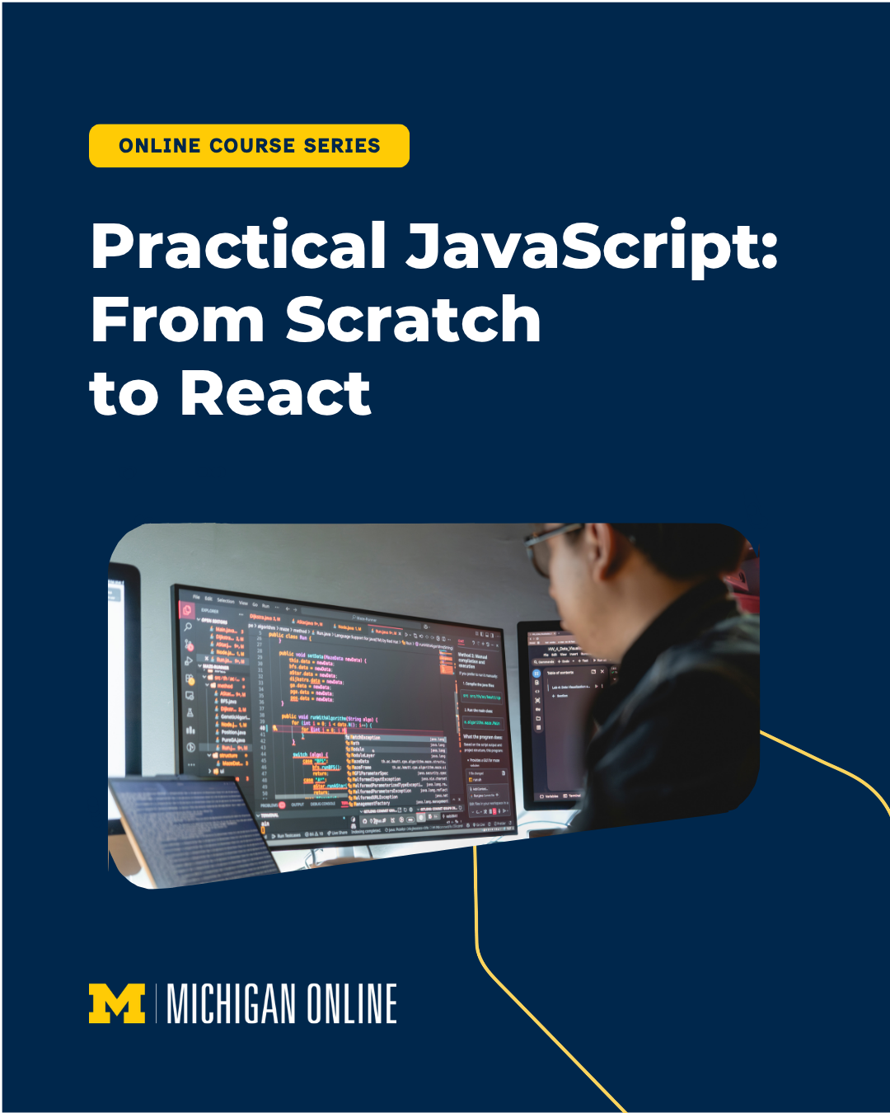

(Click image for downloadable asset)

Alt Text: Promotional graphic for the University of Michigan Online course series "Practical JavaScript: From Scratch to React," featuring a person working at a computer with code displayed on multiple monitors.

Post 4 - Social Media Promo Video

Post Copy: Moving up in your career?

Then it’s time to build the skills you need to get there. Learn how to create accessible, full-stack web applications with “Practical JavaScript: From Scratch to React.”

CTA: Start building today.

Hashtags: #JavaScript #WebDevelopment #ReactJS #Programming

URL: https://myumi.ch/pgVry

Vertical Reel 1: Optional Post Thumbnail:


(Click images for downloadable assets)

Post 5 - Vertical Reel 1

Post Copy: A great idea deserves a great user experience.

Explore JavaScript, React, and the design principles behind modern web applications while learning to create user experiences people actually enjoy.

CTA: Join us for “Practical JavaScript: From Scratch to React” on Michigan Online.

Hashtags: #JavaScript #WebDevelopment #ReactJS #Programming

URL: https://myumi.ch/pgVry

Vertical Reel 2 Optional Post Thumbnail:


(Click images for downloadable assets)

Post 6 - Vertical Reel 2

Post Copy: Have you ever accepted an AI suggestion only to realize 20 minutes later it was leading you in the wrong direction?

Michigan Online’s newest online course series, “Practical JavaScript: From Scratch to React,” provides the foundational expertise you need to stay on track as you build interactive web applications with JavaScript.

CTA: Master the skills that set great developers apart.

Hashtags: #JavaScript #WebDevelopment #ReactJS #Programming

URL: https://myumi.ch/pgVry

Vertical Reel 2 Optional Post Thumbnail:


(Click images for downloadable assets)

Post 7 - Vertical Reel 3

Post Copy: The best way to learn programming is by building something.

In “Practical JavaScript: From Scratch to React,” you’ll advance your programming skills by building accessible, dynamic webpages using JavaScript.

CTA: Master full-stack web development with JavaScript.

Hashtags: #JavaScript #WebDevelopment #ReactJS #Programming

URL: https://myumi.ch/pgVry

Vertical Reel 2 Optional Post Thumbnail:


(Click images for downloadable assets)

