About This Toolkit
This Social Media Toolkit makes it easy to share “Anatomy” course series content across your social channels. On the following pages, you’ll find ready-to-post graphics and/or videos, copy, and URL links designed for usage across Facebook, Instagram, LinkedIn, and X. Feel free to edit the post copy to fit your voice across your accounts.

We’d love it if you tagged us!

Facebook- @MichiganOnline
Instagram- @michigan.online
LinkedIn- @Michigan Online

Series Graphic:
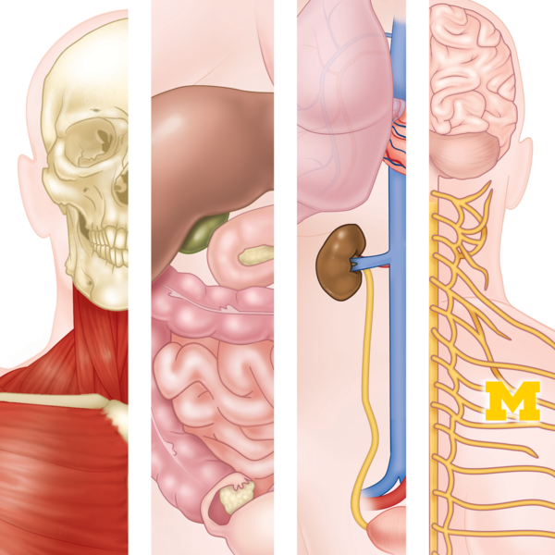

(Click image for downloadable asset)

Alt Text: Four-panel anatomical illustration showing the skeletal, digestive, urinary, and nervous systems of the human body.

Individual Course Graphics:

Alt Text Image 1: Anatomical illustration of the upper body showing the skull, neck muscles, and shoulder muscles.

Alt Text Image 2: Anatomical illustration of the upper torso showing the lungs, heart, kidneys, major blood vessels, and ureters.

Alt Text Image 3: Anatomical illustration showing the brain, spinal cord, and branching nerves of the upper body.

Alt Text Image 4: Anatomical illustration of the abdomen showing major digestive organs, including the liver, stomach, and intestines.

Course 1 Course 2
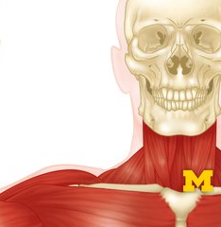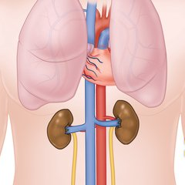
Course 3 Course 4
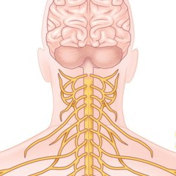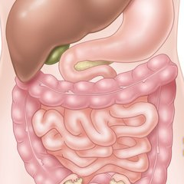

(Click images for downloadable assets)

Post 1- Course Graphic Carousel:

Post Copy: Understanding the human body starts with anatomy. Build the knowledge to pursue your goals in health science with the guidance of the @University of Michigan Medical School faculty.

Our newly updated online “Anatomy” course series gives you a comprehensive foundation in the structure, terminology, and organization of the human body. Using immersive 3D anatomical models and a flexible, systems-based approach, you can build your knowledge across major organ systems or focus on the areas most relevant to your goals.

CTA: Gain the anatomy knowledge to move forward with confidence. Explore the course series on Michigan Online.

Hashtags: #HumanAnatomy #HealthSciences #HealthcareEducation #MichiganMedicine

URL: https://myumi.ch/WDp7A

Slide 1 Slide 2
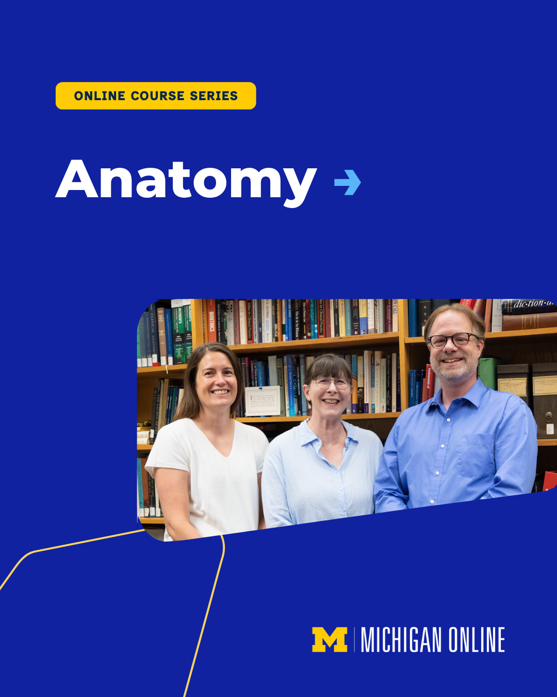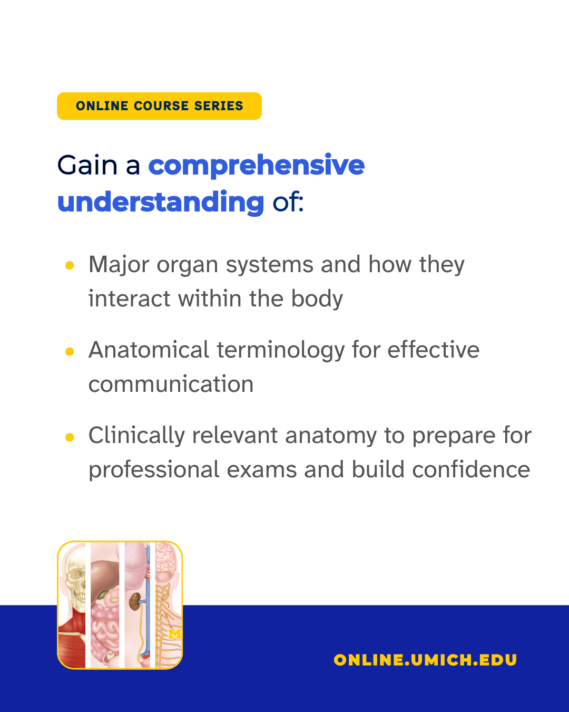

Slide 3 Slide 4
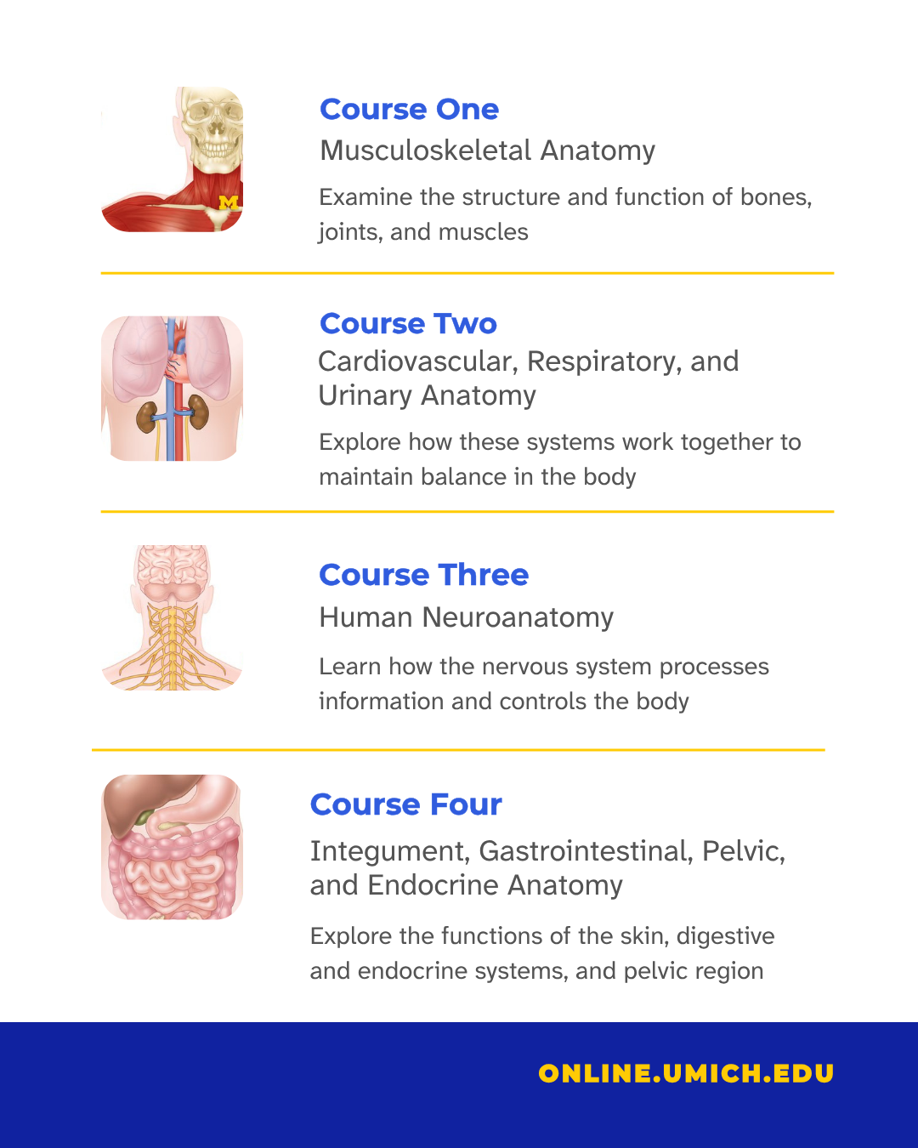

(Click image for downloadable asset)

Course Graphic Carousel Alt Text:

Alt Text Slide 1: Michigan Online graphic for an online Anatomy course series, featuring three instructors standing in front of bookshelves.

Alt Text Slide 2: Michigan Online Anatomy course series graphic stating that learners will gain a comprehensive understanding of major organ systems and their interactions, anatomical terminology for effective communication, and clinically relevant anatomy for professional exams and confidence building. A small illustration at the bottom shows several human anatomical systems.

Alt Text Slide 3: Michigan Online Anatomy course series graphic listing four courses covering musculoskeletal anatomy; cardiovascular, respiratory, and urinary anatomy; human neuroanatomy; and integument, gastrointestinal, pelvic, and endocrine anatomy. The web address “online.umich.edu” appears at the bottom.

Alt Text Slide 4: Michigan Online promotional graphic for the Anatomy online course series, inviting learners to enroll at online.umich.edu.

Post 2 - Quote Graphics:

Post Copy: Anatomy can be complex. Michigan Online’s “Anatomy” course series helps you make sense of it.

CTA: Find what you need to build your anatomy foundation on Michigan Online.

Hashtags: #HumanAnatomy #HealthSciences #HealthcareEducation #MichiganMedicine

URL: https://myumi.ch/WDp7A

Primary Image: Secondary Image:

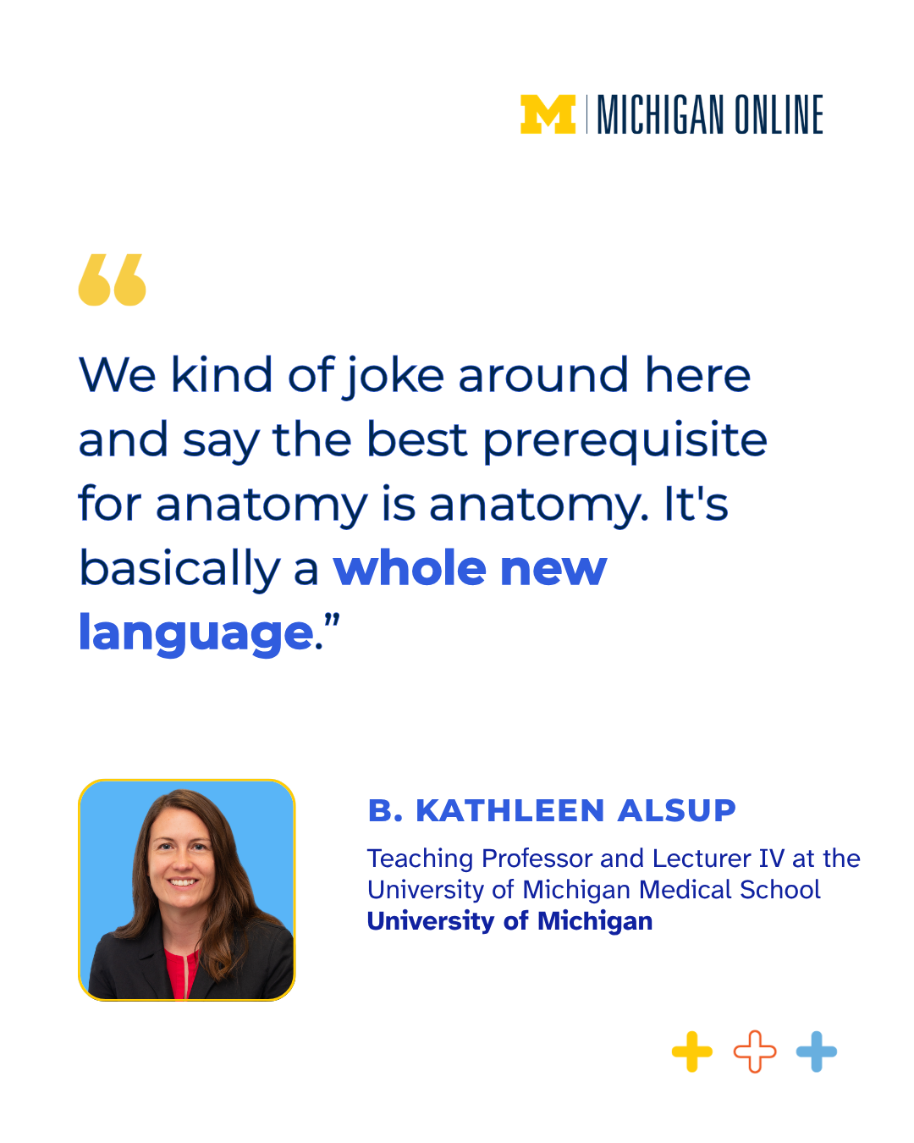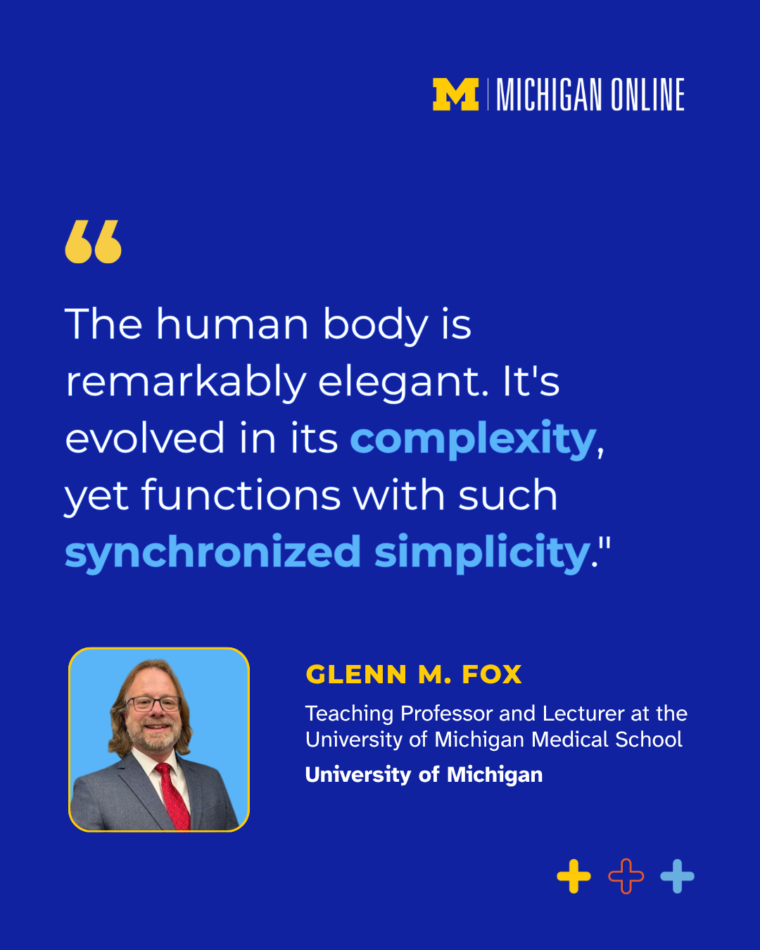

(Click image for downloadable asset)

Alt Text Primary Image: Michigan Online graphic featuring a portrait and quote from B. Kathleen Alsup: “We kind of joke around here and say the best prerequisite for anatomy is anatomy. It’s basically a whole new language.”

Alt Text Secondary Image: Michigan Online graphic featuring a portrait and quote from Glenn M. Fox: “The human body is remarkably elegant. It’s evolved in its complexity, yet functions with such synchronized simplicity.”

Post 3- Graphic Image Post
Post Copy: Understanding anatomy goes beyond memorization.

Build, refresh, or strengthen your understanding of the human body with an updated four-course “Anatomy” series from @University of Michigan Medical School faculty. Explore nine major organ systems and regions through a systems-based curriculum designed to connect anatomical structures with their functions and relationships.

In this Anatomy series, you’ll:
🩻 Build the anatomical vocabulary and structural knowledge needed for advanced healthcare study
🫀 Explore high-fidelity, donor-derived 3D models to see anatomy in authentic contexts
🧠 Target specific knowledge gaps with focused courses covering the body’s major systems and regions
🫁 Build skills and knowledge for professional training, clinical learning, and healthcare exams

CTA: Strengthen your anatomy foundation with Michigan Online.
Hashtags: #HumanAnatomy #HealthSciences #HealthcareEducation #MichiganMedicine

URL: https://myumi.ch/WDp7A

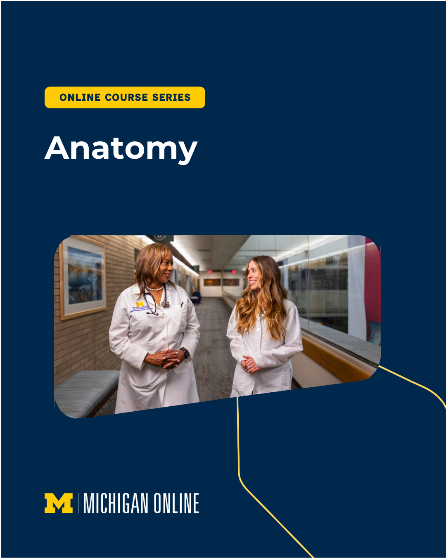

(Click image for downloadable asset)

Alt Text: Michigan Online promotional graphic for an Anatomy online course series, featuring two medical professionals in white coats talking in a hallway.

Post 4 - Vertical Reel 1

Post Copy: The human body doesn’t work one system at a time.

In our “Anatomy” online course series, explore how structures and systems connect, from the muscles that create movement to the nervous system that helps control it. Interactive 3D models help you see those relationships in context and build a more complete understanding of human anatomy.

CTA: See how the body comes together. Explore “Anatomy” on Michigan Online.

Hashtags: #HumanAnatomy #HealthSciences #HealthcareEducation #MichiganMedicine

URL: https://myumi.ch/WDp7A

Vertical Reel 1: Optional Post Thumbnail:


(Click images for downloadable assets)

Post 5 - Vertical Reel 2

Post Copy: The more you explore anatomy, the more connections you begin to see.

Whether you’re working through an anatomy course now or returning to concepts you learned years ago, another look at a structure can help you see the details and how it fits into the bigger picture.

The “Anatomy” course series from Michigan Online gives you another way to explore complex concepts, revisit specific body systems, and reinforce what you know.

CTA: Deepen your understanding of anatomy, one system at a time.

Hashtags: #HumanAnatomy #HealthSciences #HealthcareEducation #MichiganMedicine

URL: https://myumi.ch/WDp7A

Vertical Reel 2 Optional Post Thumbnail:


(Click images for downloadable assets)

Post 6 - Vertical Reel 3

Post Copy: Explore the human body in depth.

The “Anatomy” course series uses 3D models derived from anatomical donors to help learners explore structures from different perspectives and better understand their dimensions, position, and relationships within the body.

CTA: Explore anatomy from every angle on Michigan Online.

Hashtags: #HumanAnatomy #HealthSciences #HealthcareEducation #MichiganMedicine

URL: https://myumi.ch/WDp7A

Vertical Reel 2 Optional Post Thumbnail:


(Click images for downloadable assets)

