About This Toolkit
This Social Media Toolkit makes it easy to share “Democracy and Civic Engagement Teach-Out®” content across your social channels. On the following pages, you’ll find ready-to-post graphics and/or videos, copy, and URL links designed for usage across Facebook, Instagram, LinkedIn, and X. Feel free to edit the post copy to fit your voice across your accounts.

We’d love it if you tagged us!

Facebook- @MichiganOnline
Instagram- @michigan.online
LinkedIn- @Michigan Online

Course Graphic:
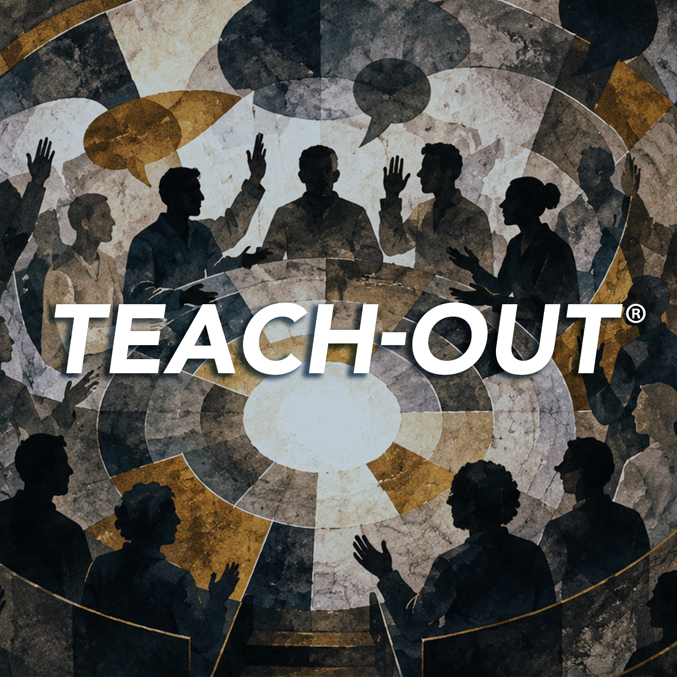
(Click image for downloadable asset)

Alt Text: Silhouettes of a diverse group of people gather in discussion, with several raising their hands or gesturing beneath overlapping speech bubbles. Large white text reading “TEACH-OUT®” spans the center of the circular, collage-style design.

Post 1- Course Graphic Carousel:

Post Copy: Democracy isn’t just a group of powerful people making proclamations from Washington. Democracy shows up in your city council meetings, on your ballot, and in the headlines you scroll past every day.

The “Democracy and Civic Engagement” Teach-Out® breaks down how governments, elections, and institutions actually function, and what puts them at risk. Go beyond political clickbait with @University of Michigan faculty who connect the workings of democracy to the world around you. Free to join and open to learners around the world.

CTA: Explore how democracy works, how it is challenged, and how it can be strengthened.

Hashtags: #MichiganOnline #Democracy #CivicEngagement #UMich

URL: https://myumi.ch/VDrXJ

Slide 1: Slide 2:
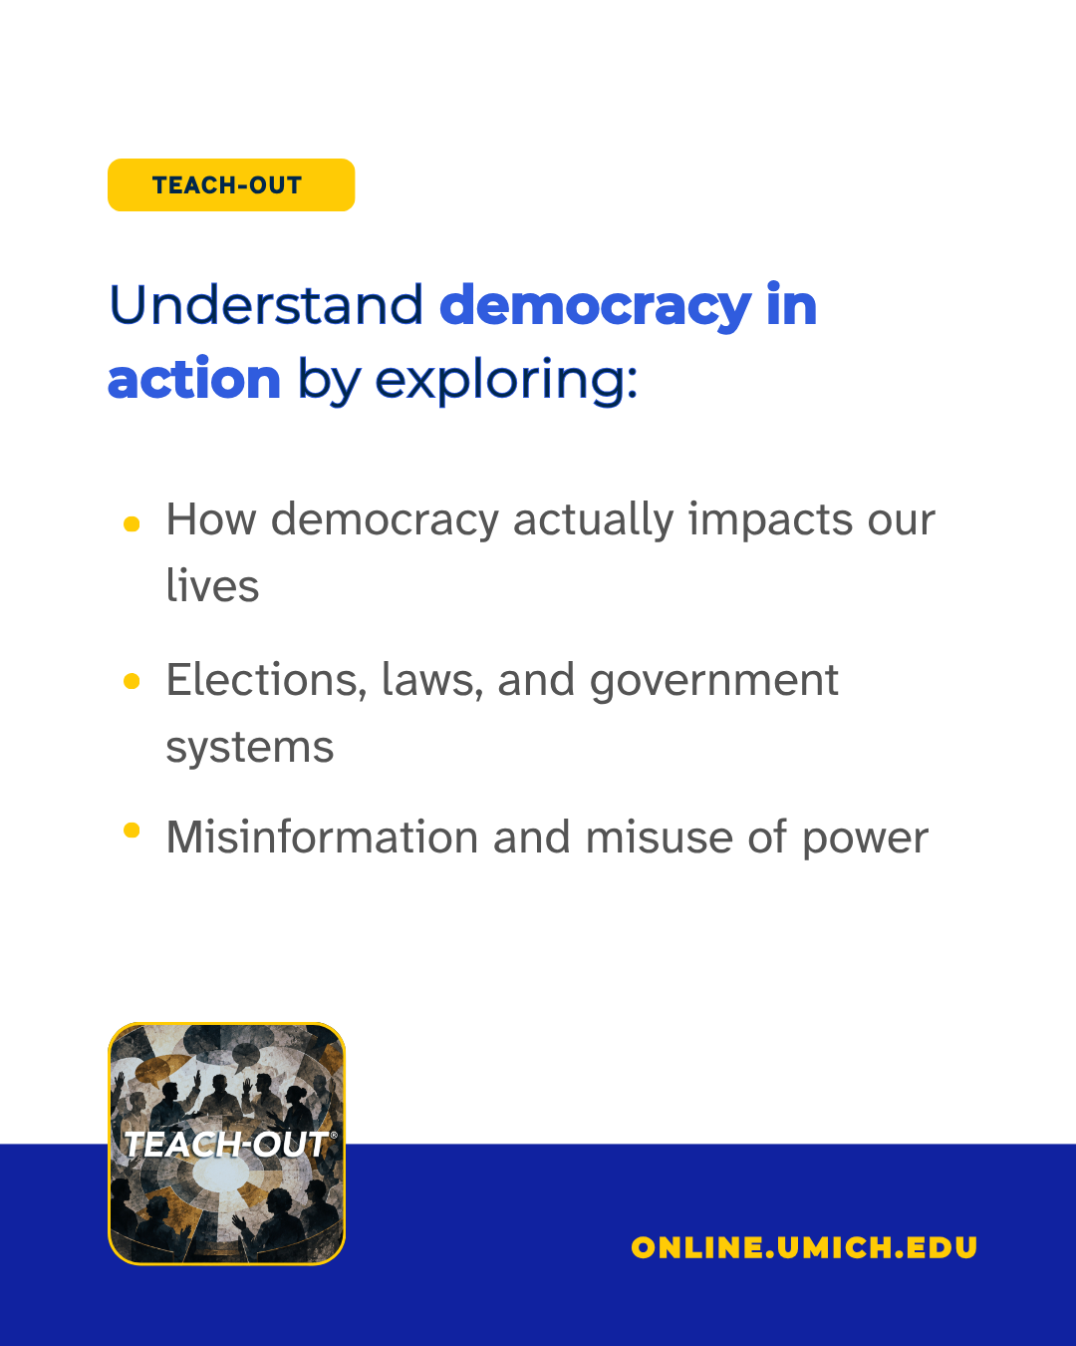

(Click images for downloadable assets)

Alt Text Slide 1 Image: Michigan Online graphic for a Teach-Out titled “Democracy and Civic Engagement,” featuring portraits of a smiling woman and man.

Alt Text Slide 2 Image: Teach-Out graphic reading, “Understand democracy in action by exploring:” followed by three topics: how democracy actually impacts our lives; elections, laws, and government systems; and misinformation and misuse of power. The Michigan Online website, “online.umich.edu,” appears at the bottom.

Post 2 - Quote Graphics:

Post Copy: Democracy runs on one core idea: people hold the power to decide how they’re governed.

In the “Democracy and Civic Engagement” Teach-Out®, faculty break down the methods that make the system work, and the forces that put it at risk. Access this Teach-Out for free, wherever you are, through November 14th, 2026, on @Coursera!

CTA: Learn practical ways to strengthen democracy in your community.

Hashtags: #MichiganOnline #Democracy #CivicEngagement #UMich

URL: https://myumi.ch/VDrXJ

Slide 1: Slide 2:

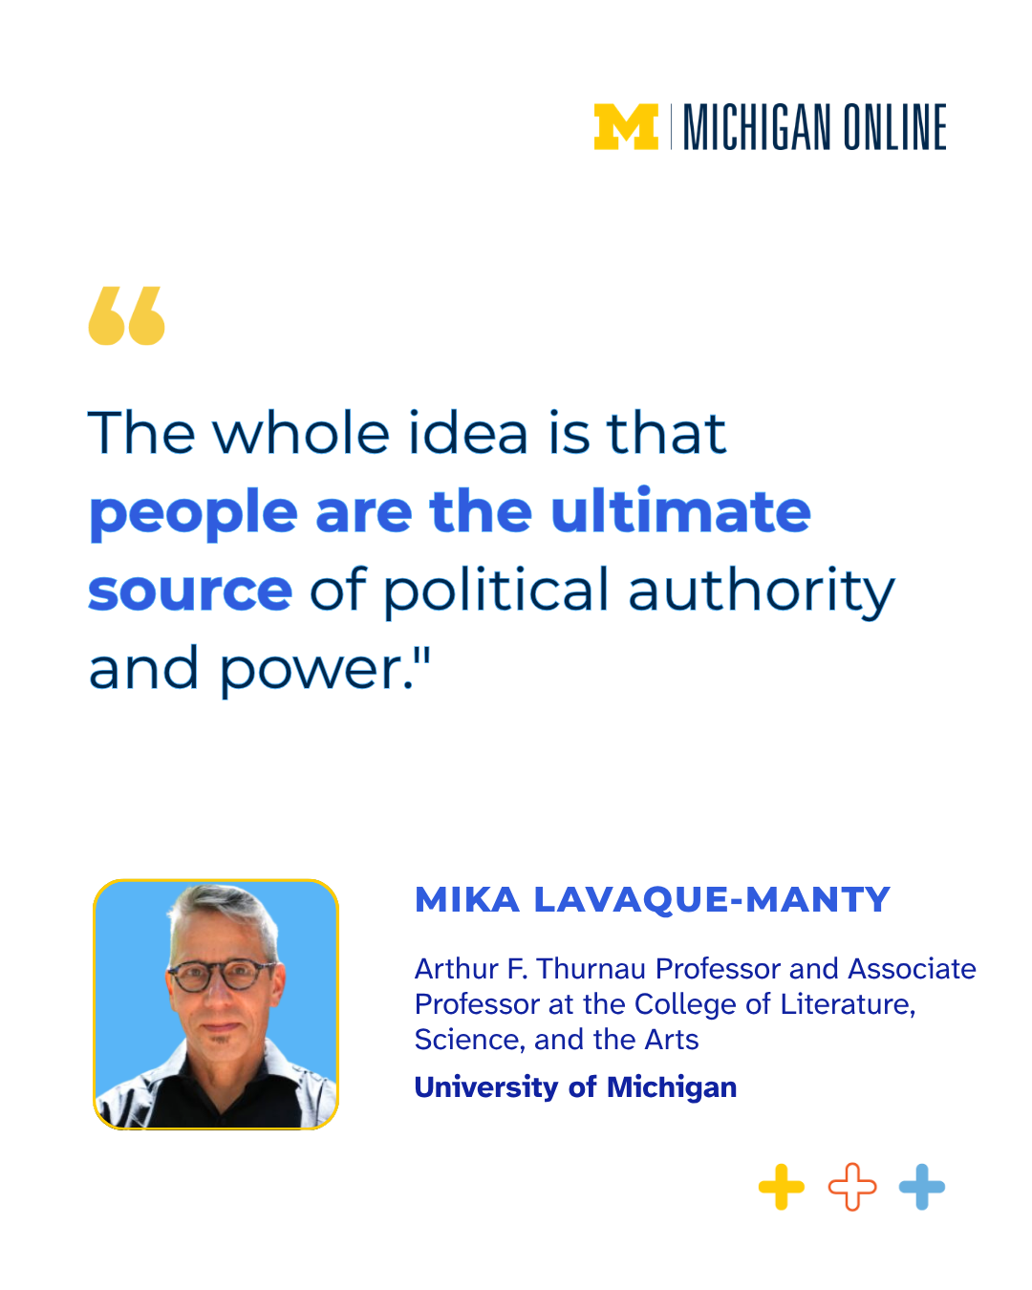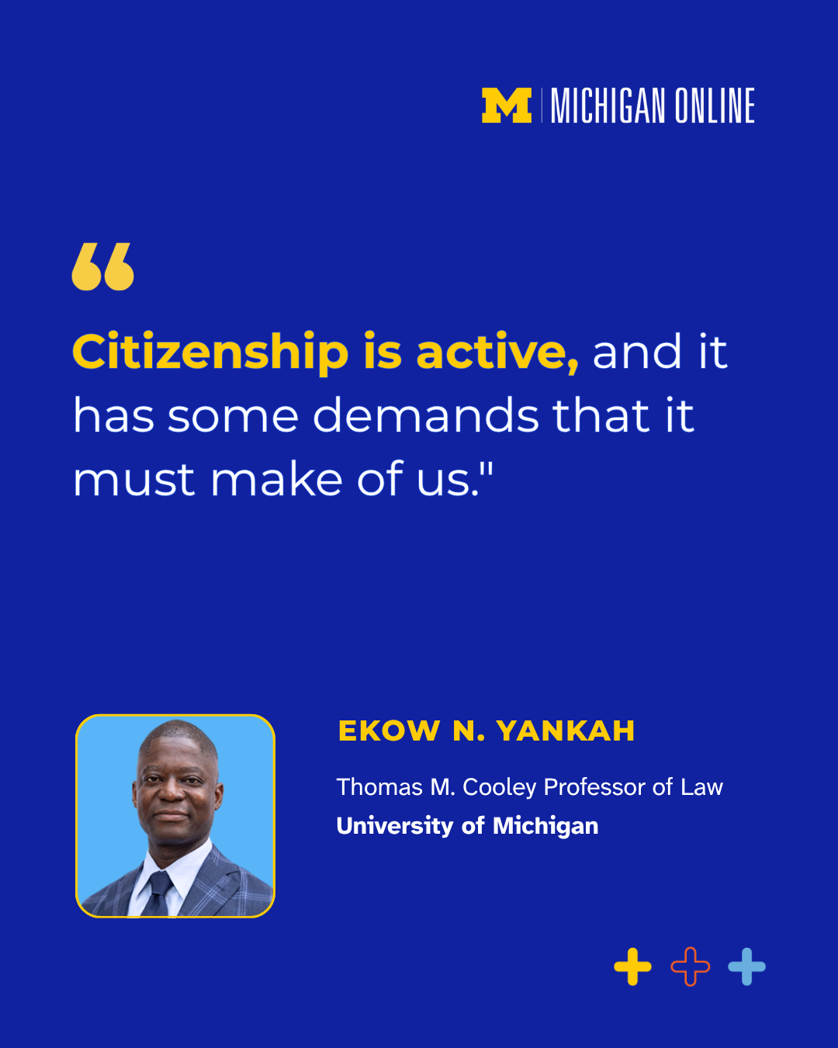

(Click images for downloadable assets)

Alt Text Slide 1 Image: Michigan Online quote graphic featuring Mika Lavaque-Manty of the University of Michigan: “The whole idea is that people are the ultimate source of political authority and power.” A portrait of Lavaque-Manty appears below the quote alongside his academic title.

Alt Text Slide 2 Image: Michigan Online quote graphic featuring Ekow N. Yankah of the University of Michigan: “Citizenship is active, and it has some demands that it must make of us.” A portrait of Yankah appears below the quote with his title, Thomas M. Cooley Professor of Law.

Post 3- Graphic Image Post

Post Copy: Losing an election doesn’t mean losing your voice. Democracy depends on people accepting that today's opposition is tomorrow’s legitimate contender, and that pluralism makes space for multiple points of view.

CTA: Turn your understanding into action. Join the Democracy and Civil Engagement Teach-Out®.

Hashtags: #MichiganOnline #Democracy #CivicEngagement #UMich

URL: https://myumi.ch/VDrXJ



(Click image for downloadable asset)

Alt Text: graphic for the Michigan Online Teach-Out “Democracy and Civic Engagement.” A smiling woman speaks into a megaphone while standing in front of a diverse crowd of people who are clapping and gathered outdoors.

Post 4 - Event Post 1

Post Copy: From election headlines to misinformation in your feed, understanding democracy helps you navigate today’s political landscape.

Join @University of Michigan experts for a live, online conversation exploring how democratic systems work, the challenges they face, and the role everyday people can play in protecting them.

Part of the new “Democracy and Civic Engagement” Teach-Out®, this event extends the conversation beyond the course with expert perspectives on political institutions, misinformation, accountability, civic participation, and more.

📅 Date: October 14th, 2026
⏰ Time: 2:00 - 3:00 PM

CTA: Bring your questions and join the conversation.

URL: https://myumi.ch/VDrXJ

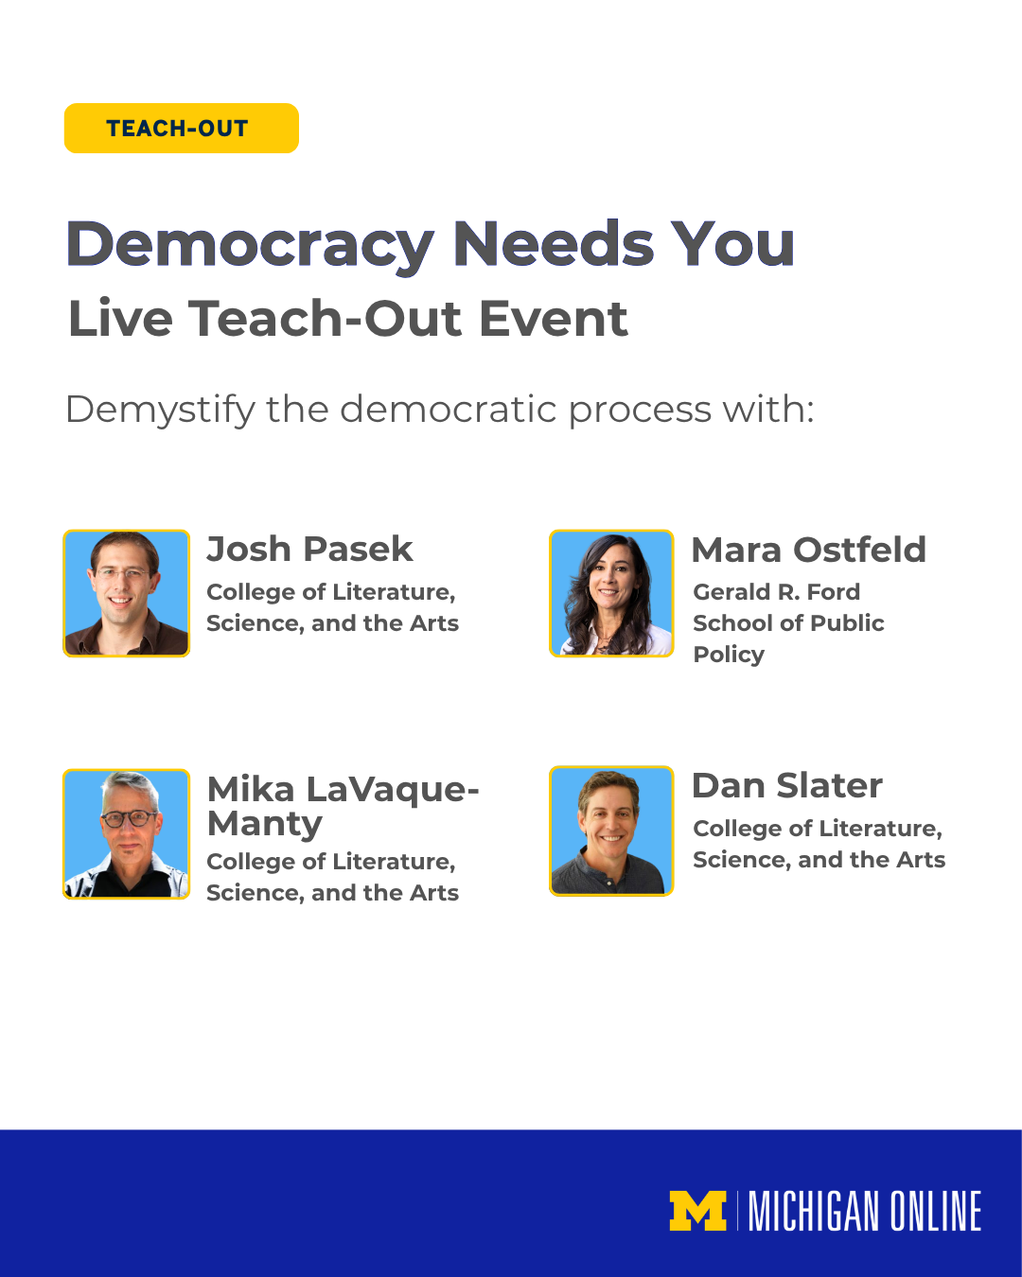

(Click images for downloadable assets)

Alt Text: Michigan Online Teach-Out graphic for the “Democracy Needs You” Live Event, inviting participants to “Demystify the democratic process” with Josh Pasek, Mara Ostfeld, Mika LaVaque-Manty, and Dan Slater. Headshots of all four speakers accompany their names and University of Michigan affiliations.

Post 5 - Event Post 2

Post Copy: Democracy depends on meaningful participation and understanding how the system works.

Join us live online to go beyond the daily political noise with a panel of @University of Michigan faculty to explore some of the bigger questions shaping democracy today:

• How can people hold political leaders accountable?
• What role does the media play in our political system?
• What can individuals and communities do to strengthen democracy?

Ask questions, hear multiple perspectives, and leave with practical ideas for more informed civic participation.

📅 Date: October 14th, 2026
⏰ Time: 2:00 - 3:00 PM

CTA: Save your spot now:

URL: https://myumi.ch/VDrXJ



(Click images for downloadable assets)

Alt Text: Michigan Online Teach-Out graphic promoting “Democracy Need You,” a live Zoom webinar on October 14, 2026, from 2–3 PM. Featured speakers are Josh Pasek, Mara Ostfeld, Mika LaVaque-Manty, and Dan Slater, with headshots and University of Michigan affiliations.

